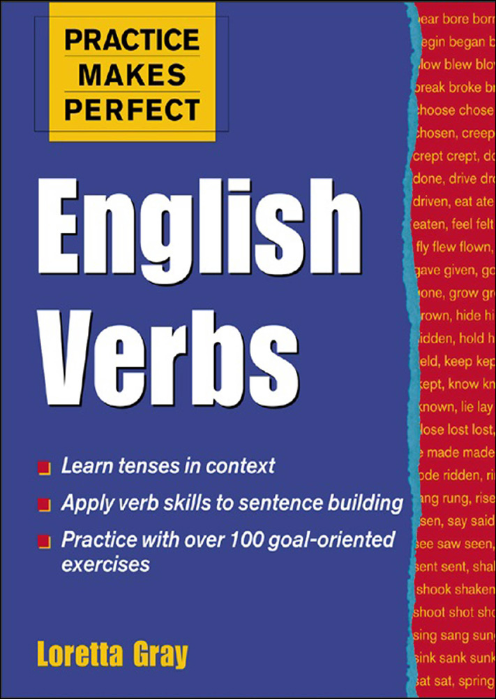

Table of Contents
Cover Page
Practice Makes Perfect: English Verbs
Copyright Page
Contents
Introduction
PART I THE PRESENT TENSE
Unit 1 Simple Present
Unit 2 Be Verb Forms
Unit 3 Present Progressive (Be Verb + -ing)
Unit 4 Present Perfect
Unit 5 Present Perfect Progressive
PART II THE PAST TENSE
Unit 6 Simple Past
Unit 7 Be Verb Forms
Unit 8 Past Progressive (Be Verb + -ing)
Unit 9 Past Perfect
Unit 10 Past Perfect Progressive
PART III THE FUTURE TENSE
Unit 11 Simple Future
Unit 12 Be Going To
Unit 13 Future Progressive (Will Merb + -ing)
Unit 14 Future Perfect
Unit 15 Future Perfect Progressive
PART IV IMPERATIVE, PASSIVE, AND HYPOTHETICAL CONDITIONAL
Unit 16 Imperative
Unit 17 Passive
Unit 18 Hypothetical Conditional
PART V PHRASAL VERBS AND MODAL AUXILIARY VERBS
Unit 19 Phrasal Verbs
Unit 20 Modal Auxiliary Verbs
PART VI GERUND AND INFINITIVE COMPLEMENTS
Unit 21 Gerunds
Unit 22 Infinitives
Unit 23 Gerunds or Infinitives
APPENDIX Chart of Irregular Verbs
Glossary
Answer Key
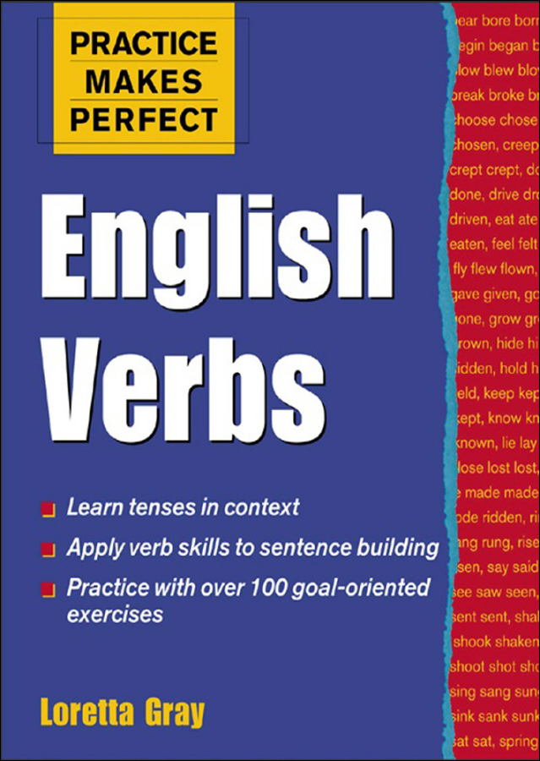
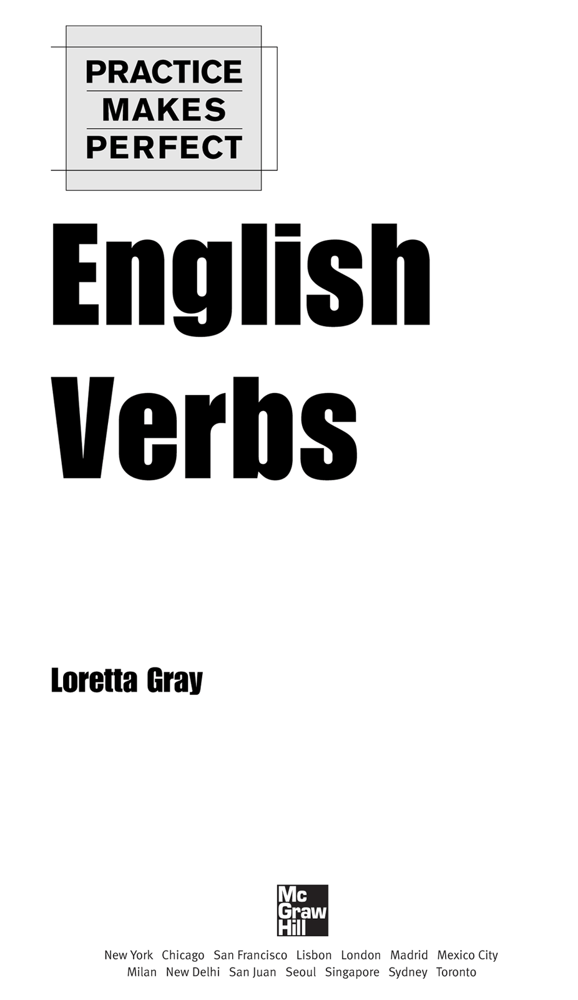
Copyright © 2004 by The McGraw-Hill Companies, Inc. All rights reserved. Except as permitted under the United States Copyright Act of 1976, no part of this publication may be reproduced or distributed in any form or by any means, or stored in a database or retrieval system, without the prior written permission of the publisher.
ISBN: 978-0-07-177171-9
MHID: 0-07-177171-9
The material in this eBook also appears in the print version of this title: ISBN: 978-0-07-142646-6, MHID: 0-07-142646-9.
All trademarks are trademarks of their respective owners. Rather than put a trademark symbol after every occurrence of a trademarked name, we use names in an editorial fashion only, and to the benefit of the trademark owner, with no intention of infringement of the trademark. Where such designations appear in this book, they have been printed with initial caps.
McGraw-Hill eBooks are available at special quantity discounts to use as premiums and sales promotions, or for use in corporate training programs. To contact a representative please e-mail us at bulksales@mcgraw-hill.com.
TERMS OF USE
This is a copyrighted work and The McGraw-Hill Companies, Inc. (“McGraw-Hill”) and its licensors reserve all rights in and to the work. Use of this work is subject to these terms. Except as permitted under the Copyright Act of 1976 and the right to store and retrieve one copy of the work, you may not decompile, disassemble, reverse engineer, reproduce, modify, create derivative works based upon, transmit, distribute, disseminate, sell, publish or sublicense the work or any part of it without McGraw-Hill’s prior consent. You may use the work for your own noncommercial and personal use; any other use of the work is strictly prohibited. Your right to use the work may be terminated if you fail to comply with these terms.
THE WORK IS PROVIDED “AS IS.” McGRAW-HILL AND ITS LICENSORS MAKE NO GUARANTEES OR WARRANTIES AS TO THE ACCURACY, ADEQUACY OR COMPLETENESS OF OR RESULTS TO BE OBTAINED FROM USING THE WORK, INCLUDING ANY INFORMATION THAT CAN BE ACCESSED THROUGH THE WORK VIA HYPERLINK OR OTHERWISE, AND EXPRESSLY DISCLAIM ANY WARRANTY, EXPRESS OR IMPLIED, INCLUDING BUT NOT LIMITED TO IMPLIED WARRANTIES OF MERCHANTABILITY OR FITNESS FOR A PARTICULAR PURPOSE. McGraw-Hill and its licensors do not warrant or guarantee that the functions contained in the work will meet your requirements or that its operation will be uninterrupted or error free. Neither McGraw-Hill nor its licensors shall be liable to you or anyone else for any inaccuracy, error or omission, regardless of cause, in the work or for any damages resulting therefrom. McGraw-Hill has no responsibility for the content of any information accessed through the work. Under no circumstances shall McGraw-Hill and/or its licensors be liable for any indirect, incidental, special, punitive, consequential or similar damages that result from the use of or inability to use the work, even if any of them has been advised of the possibility of such damages. This limitation of liability shall apply to any claim or cause whatsoever whether such claim or cause arises in contract, tort or otherwise.
Contents
Introduction
PART I The Present Tense
Unit 1 Simple Present
Unit 2 Be Verb Forms
Unit 3 Present Progressive (Be Verb + -ing)
Unit 4 Present Perfect
Unit 5 Present Perfect Progressive
PART II The Past Tense
Unit 6 Simple Past
Unit 7 Be Verb Forms
Unit 8 Past Progressive {Be Verb + -ing)
Unit 9 Past Perfect
Unit 10 Past Perfect Progressive
PART III The Future Tense
Unit 11 Simple Future
Unit 12 Be Going To
Unit 13 Future Progressive {Will Be Verb + -ing)
Unit 14 Future Perfect
Unit 15 Future Perfect Progressive
PART IV Imperative, Passive, and Hypothetical Conditional
Unit 16 Imperative
Unit 17 Passive
Unit 18 Hypothetical Conditional
PART V Phrasal Verbs and Modal Auxiliary Verbs
Unit 19 Phrasal Verbs
Unit 20 Modal Auxiliary Verbs
PART VI Gerund and Infinitive Complements
Unit 21 Gerunds
Unit 22 Infinitives
Unit 23 Gerunds or Infinitives

Appendix: Chart of Irregular Verbs
Glossary
Answer Key
Introduction
When you study English verbs, you must do more than search for their meanings in a dictionary. You must also learn how to conjugate them and use these conjugations appropriately. Most students begin their studies by memorizing verb forms. They learn both the verb endings for regular verbs and the more complicated forms of the irregular verbs. Practice Makes Perfect: English Verbs provides you with opportunities to practice conjugating more than three hundred verbs, both regular and irregular.
However, this text is more than a list of verb forms and mechanical exercises. It also presents the reasons for choosing one verb form over another. For example, you may know the dictionary meaning of walk, but to use this verb to refer to the future, you must understand your options; that is, you must understand the role of tense and aspect. To indicate future, you could say I’ll walk to school today, I’m going to walk to school today, or I’m walking to school today, but not I walk to school today.
When most people think of tense, they think of time. While it is true that tense is sometimes related to present, past, and future time, this is not always the case. In the sentence My plane leaves in twenty minutes, the simple present tense of the verb leave is used to refer to future time. As well as being marked for tense, verbs are marked for aspect. Aspect provides information about whether an action, a state, or an event has been completed and how a verb is related to other verbs in a time sequence. I study English and I am studying English are both in the present tense, but they differ in aspect. The verb in the first sentence refers to a habitual action; the verb in the second sentence refers to an action that is not yet completed. To indicate both tense and aspect, study is said to be in the simple present and am studying is said to be in the present progressive. In the sentence I had been studying for the test when the phone rang, there are two main verbs: study and ring. They are both in the past tense; however, they differ in aspect. Had been studying is the past perfect progressive, whereas rang is just the simple past. The difference in aspect indicates that the action of studying was ongoing and prior to the action of ringing. Tense and aspect intersect in the following way.
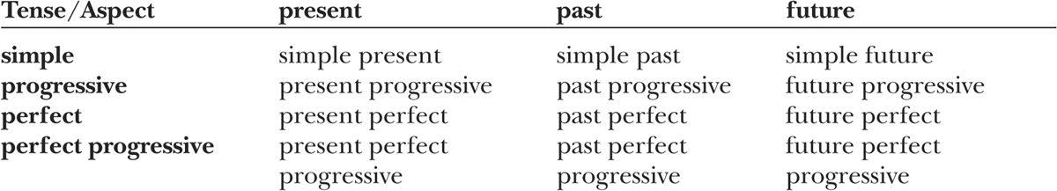
The form and meaning of each of these tense-aspect combinations will be described in the units of this book. Although you will study all the tenses mentioned in traditional textbooks, you will also study the concept of aspect so that you will have a deeper understanding of the grammatical meaning conveyed by the form of a verb. Thus, as you work through the material in Practice Makes Perfect: English Verbs, you will learn not only how to conjugate verbs but also why to use specific verb forms.
Any study of verbs would be incomplete without the inclusion of special types of verbs and complementation patterns. After you become familiar with verb conjugations, you will study phrasal verbs, modal verbs, and verb complementation (gerunds and infinitives).
This book focuses on the verbs most frequently used in English. It is appropriate for classroom use or individual study. If you are in a class, your teacher may choose to assign exercises to supplement your other coursework. If you are studying alone, you can use the Answer Key at the back of the book to check your work and decide whether you should review a chapter or go on to the next.
There are six principal parts in this book:
PART I—THE PRESENT TENSE The five units in Part I will help you learn the verb forms that constitute four different tense-aspect combinations: simple present, present progressive, present perfect, and present perfect progressive. You will practice using these forms in positive statements, negative statements, and questions. You will also learn how to form contractions with pronouns or the word not. A special section focuses on the verb be.
PART II—THE PAST TENSE The five units in Part II will help you learn four more tense-aspect combinations: simple past, past progressive, past perfect, and past perfect progressive. As in Part I, you will practice using these tense-aspect combinations and their contracted forms in positive statements, negative statements, and questions. In this part also, there is a special section focusing on the verb be.
PART III—THE FUTURE TENSE Part III differs from the others in that the modal will is introduced rather than verb endings. This part consists of five units: simple future, future progressive, future perfect, future perfect progressive, and a unit on the use of be going to. You will practice using the future tense-aspect combinations and their contracted forms in positive statements, negative statements, and questions.
PART IV—IMPERATIVE, PASSIVE, AND HYPOTHETICAL CONDITIONAL The three units in Part IV will help you learn to use verbs in special constructions not discussed earlier: imperative (Be careful!), passive (The project was finished on time.), and hypothetical conditional (If I were you, I would accept the offer.).
PART V—PHRASAL VERBS AND MODAL AUXILIARY VERBS The English language is full of phrasal verbs, which are verb-particle combinations, such as run into in run into an old friend. In the first unit of Part V, you will practice using some common phrasal verbs. The second unit of Part V focuses on modal auxiliary verbs. Although you will be introduced to modal verbs in Parts III and IV, you will learn more about the subtle shades of meaning that tense and aspect add to these verbs.
PART VI—GERUND AND INFINITIVE COMPLEMENTS Some verbs take gerunds, some take infinitive complements, and some take both. Part VI will help you learn to choose appropriate verb complements.
Practice Makes Perfect: English Verbs ends with an appendix of irregular verb forms, followed by a glossary of grammatical terms.

PART I
THE PRESENT TENSE
Verbs in the present tense occur in four forms, each signaling a different aspect. (Aspect is explained in the Introduction.) Each of these forms conveys information about an action, state, or event that is relevant now.
SIMPLE PRESENT: I study every day.
PRESENT PROGRESSIVE: I am studying right now.
PRESENT PERFECT: I have studied English for two years.
PRESENT PERFECT PROGRESSIVE: I have been studying all day for my test tomorrow.
In the following units, you will learn about these verb forms and the reasons for using them.

Unit 1 Simple Present
When you refer to habitual actions, customs, and facts, use simple present verb forms.
HABITUAL ACTION: I work in the library.
CUSTOM: Most Americans eat turkey on Thanksgiving Day.
FACT: The earth revolves around the sun.
If you include a time reference, you can also use the simple present to indicate future time.
FUTURE ACTION: The concert starts in five minutes.
Except for be and have, verbs in the simple present follow this pattern:
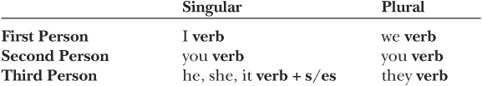
As you can see, the base form of the verb is used with the subject pronouns I, you, we, and they and with the nouns these pronouns can replace. For example, the students takes the same verb form as they. An ending, either -s or -es, is added to the verb when the subject pronoun is he, she, or it or a noun these pronouns can replace. The -s ending is used most frequently. The -es ending is used after certain letters or letter combinations.
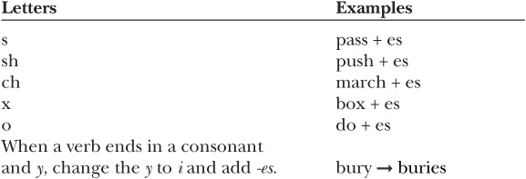
The verb be is described in Unit 2. In the following chart are the forms of the verb have:
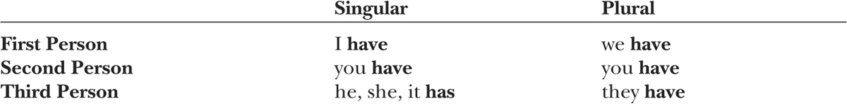
Notice that has is the verb form used with he, she, it, and the nouns these pronouns can replace.

exercise 1-1

Complete each sentence with the simple present form of the verb in parentheses. Circle the reason that the simple present is used.
1. I ______________ (eat) lunch in the cafeteria every day but Friday.
2. Julia _____________ (carry) a heavy backpack to school every day.
3. You _____________ (speak) English well.
4. The state of Florida _____________ (produce) a great deal of citrus fruit.
5. During the holidays, we always _____________ (make) special meals.
6. He ______________ (watch) television every night.
7. My roommate _______________ (say) a prayer before he eats.
8. The game _______________ (begin) in an hour.
9. My friends and I (live) near a park.
10. Trees ______________ (grow) tall in the Pacific Northwest.
11. We _____________ (wear) traditional dress on holidays.
12. Most people ______________ (shake) hands when they first ____________ (meet).

exercise 1-2

Using the pronoun and verb provided, create your own sentences.
1. She always (make .
2. I (take) .
3. It (give) .
4. They (come) .
5. I (use) .
6. He (leave) .
7. They (like) .
8. She (write) .
9. We (listen) .
10. It (contain) .
11. It (start) .
12. He (understand) .

Forming Negatives
To make a verb negative, add the auxiliary verb do and the word not before the main verb.
Remember that does is used with the pronouns he, she, and it. When does is used, the main verb has no -s or -es ending.

exercise 1-3
Make each of the following sentences negative.
EXAMPLE: I spend a lot of money.
I do not spend a lot of money.
1. He goes to school every day.
2. My roommate likes snakes.
3. You know my family.
4. The owner opens the store every day at 8:00.
5. We help our neighbors.
6. My friends send me letters.
7. I feel tired.
8. She speaks five different languages.
9. They study in the library.
10. We listen to pop music.
11. They grow tomatoes in their backyard.
12. This car runs well.

Forming Contractions
In English, verbs are often combined with other words to form contractions. These shortened forms include an apostrophe (’) to indicate missing letters. It is important to learn contractions because you will often hear them in conversation or see them in informal writing. Formal writing, though, rarely contains contractions.
The auxiliary verb do is often combined with not to form a contraction. Notice that an apostrophe indicates that the letter o is omitted:

exercise 1-4

Rewrite the sentences in exercise 1-3 using contractions.
1.
2.
3.
4.
5.
6.
7.
8.
9.
10.
11.
12.

Forming Yes/No Questions
To form questions that can be answered yes or no (yes/no questions), begin the question with the auxiliary verb do. After the auxiliary verb, place the subject and the main verb.

Statement: He rides his bicycle to school.
Yes/no question: Does he ride his bicycle to school?

Statement: They ride the bus to work.
Yes/no question: Do they ride the bus to work?

exercise 1-5
Rewrite the following statements as yes/no questions.
EXAMPLE: You get tired easily.
Do you get tired easily?
1. The artist shows his work at a local gallery.
2. They meet on Thursday mornings.
3. She works hard.
4. You commute to work.
5. It seems like a good decision.
6. This work requires patience.
7. The Carsons live in a small town.
8. You don’t believe my story. (Notice that do has already been used to indicate negation.)
9. The patient feels better.
10. The lecture ends at 5:30.
11. The plot involves many characters.
12. Most students complete the program in four years.

Forming Wh-Questions
Wh-questions are used to elicit specific pieces of information. They usually begin with what, who, why, where, when, how, or combinations such as how much, how many, and how often. When the question word is the subject of the sentence, the form of the question is similar to the form of a statement.

Statement: Max needs a new key.
Wh-question: Who needs a new key?

Statement: Something is wrong.
Wh-question: What is wrong?
When the question word is any other part of the sentence, the auxiliary verb do comes after the question word and is followed by the subject and the main verb.

Statement: She collects butterflies.
Wh-question: What does she collect?

Statement: They live on the coast of Maine.
Wh-question: Where do they live?

exercise 1-6

Complete the following questions based on the statements provided.
EXAMPLE: The performance starts at 7:00.
When does the performance start?
1. The person in the back row knows the answer.
Who
2. She looks healthy.
How
3. They always go to that restaurant because they like the food.
Why
4. They go golfing twice a week.
How often
5. We turn left at the corner.
Where
6. The notebook costs $3.00.
How much
7. My mother worries too much.
Who
8. You exercise every day at the gym.
How often
9. Jerry and Carol repair computers.
What
10. She teaches English.
What
11. Mark blames other people for his problems.
Whom
(Who may be used instead of whom in conversation and informal writing.)
12. Many people go to Cape Cod for their vacations.
Where
Unit 2 Be Verb Forms
The verb be has three different forms in the simple present: am, is, and are.
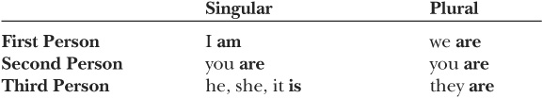

exercise 2-1

Complete each sentence with the simple present form of the verb be.
1. I _____________ a student.
2. You _____________ taller than I _____________.
3. My parents _____________ on vacation.
4. Misuzu _____________ from San Francisco.
5. My roommate’s name _____________ Chris.
6. They _____________ late again.
7. We _____________ ready for the test.
8. I _____________ interested in all kinds of sports.
9. It _____________ easy.
10. Your coat _____________ in the closet.
11. She _____________ the director.
12. They _____________ in class together.
The word there is often used with the verb be to acknowledge the existence of someone or something. The form of the be verb is based on the subject that follows it.

SINGULAR SUBJECT: There is a concert in the park tonight.
PLURAL SUBJECT: There are four rooms in the house.

exercise 2-2

Circle the verb that agrees in number with the subject that follows it.
1. There is/are someone at the door.
2. There is/are several parks in the town.
3. There is/are fifty-two cards in a deck.
4. There is/are a restroom at the end of the hall.
5. There is/are sixteen students in the class.
6. There is/are a bank on the corner of Lincoln and Ash.
7. There is/are an information booth in the lobby.
8. There is/are many specialty stores in the Mall of America.
9. There is/are still tickets available.
10. There is/are a typo on page 3.
11. There is/are a huge fountain in front of the building.
12. There is/are only one possible answer to the question.

Forming Contractions: Pronouns and There with Am, Is, and Are
Contractions are often formed by combining pronouns and the verb be. The word there can also be combined with be. It is important to learn these contractions because you will often hear them in conversation or see them in informal writing. However, you should avoid using them in formal writing.
Notice that an apostrophe indicates that a letter is omitted:
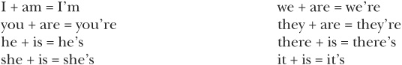

exercise 2-3
Rewrite each sentence using a contraction.
EXAMPLE: He is not here today.
He’s not here today.
1. She is a student.
2. I am an engineer.
3. There is a test on Tuesday.
4. You are next.
5. It is difficult.
6. We are from Canada.
7. He is a supervisor.
8. They are really funny.
9. I am sick today.
10. There is a package for you on the table.
11. He is first on the list.
12. It is cold in here.

Forming Negatives
To make the verb be negative, just add not.

exercise 2-4

Using contractions, make each of the sentences in exercise 2-3 negative.
1.
2.
3.
4.
5.
6.
7.
8.
9.
10.
11.
12.

Forming Contractions: Isn’t and Aren’t
The word not can be contracted with the verb forms is and are.

exercise 2-5

Complete the sentences using either isn’t or aren’t.
1. There _____________ a ball game tonight.
2. There _____________ any rooms available.
3. There _____________ a full moon tonight.
4. There _____________ any cookies left.
5. There _____________ many people here today.
6. There _____________ much time.

Forming Yes/No Questions
To form yes/no questions, begin the question with a form of the verb be and place the subject after it.

Statement: Nancy is a doctor.
Yes/no question: Is Nancy a doctor?

Statement: They are friendly.
Yes/no question: Are they friendly?
To form yes/no questions with there, place there after the be verb.

Statement: There is a gas station near the freeway.
Yes/no question: Is there a gas station near the freeway?

exercise 2-6

Rewrite the following statements as yes/no questions.
EXAMPLE: It is late.
Is it late?
1. Portland is in the state of Oregon.
2. Your car is in the garage.
3. He is in a good mood.
4. They are friends.
5. Sam is depressed.
6. Her computer is broken.
7. There are many items on the menu.
8. The coffee is too hot.
9. The city hall is the oldest building in town.
10. There is a bank near here.
11. The museum is open on Thursday evenings.
12. The lights are off.

Forming Wh-Questions
To form Wh-questions, place the be verb after the question word. When the question word is the subject of the sentence, the form of the question is similar to the form of a statement.

Statement: Someone is at the door.
Wh-question: Who is at the door?
When the question word is any other part of the sentence, the subject follows the be verb.

Statement: She is from Colorado.
Wh-question: Where is she from?

Statement: His birthday is July 11.
Wh-question: When is his birthday?

exercise 2-7

Complete the following questions based on the statements provided.
EXAMPLE: YOU are twenty-two years old.
How old are you?
1. Kevin Lee is the editor of the local newspaper.
Who
2. She is five feet tall.
How tall
3. They are visitors from another school.
Who
4. His roommate is at work right now.
Where
5. The graduation ceremony is on Saturday.
When
6. The house is white.
What color
7. That is a bike lock.
What
8. The scissors are in the drawer.
Where
9. Sandy Craig is the producer.
Who
10. The children are at their grandmother’s house.
Where
11. The library is open until 8:00.
How late
12. They are in the cafeteria.
Where

Unit 3 Present Progressive (Be Verb + -ing)
When you refer to a temporary situation or an activity in progress, use the present progressive.
TEMPORARY SITUATION: I am working in the library this term.
ACTIVITY IN PROGRESS: She is studying right now.
If you include a time reference, you can also use the present progressive to indicate future time.
FUTURE TIME: My parents are coming tomorrow.
The present progressive consists of the auxiliary verb be and the -ing form of the main verb. The auxiliary verb is marked for tense.
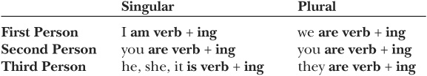
When a one-syllable word or a word with a stressed final syllable ends in a single consonant sound, double the last letter before adding -ing.
One-syllable word: run → running
Word ending in a stressed syllable: admit → admitting
BUT mow → mowing [This word ends in a vowel sound.]
When a word ends with a consonant and the letter e, drop the e before adding -ing: come → coming. The letter e is not dropped from words such as be, see, and free.

exercise 3-1
Complete each sentence with the present progressive form of the verb in parentheses. Circle the reason that the present progressive is used.
1. I ______________ (study) English this term.
2. We ______________ (go) home tomorrow.
3. Right now, I ______________ (write) a letter.
4. The bus ______________ (pull) up to the curb at this very moment.
5. They ______________ (move) to Florida at the end of the month.
6. The kids____________(act) silly right now.
7. I ______________ (use) my friend’s car today.
8. We ______________ (eat) early tonight.
9. The company____________(have) problems this year.
10. My neighbor ___________(mow) his lawn.
11. I ______________ (turn) in my paper tomorrow.
12. Steve ______________ (live) with his cousin this year.
13. It ______________ (snow).
14. Several police officers ______________ (stand) in front of the store.
15. You ______________ (speak) too loudly.
16. The sky ______________ (grow) dark.

exercise 3-2

Complete each sentence with either the simple present or the present progressive. If you need help, review pages 3-4 and 19.
1. Jim ______________ (sell) cars for a living.
2. Jim ______________ (sell) his car to his sister.
3. I ______________ (boil) some water for tea.
4. Water ______________ (boil) at one hundred degrees centigrade.
5. We always ______________ (visit) our grandparents during the holidays.
6. This year we ______________ (visit) our grandparents during the holidays.
7. Jean ______________ (go) to a lot of movies.
8. Jean ______________ (go) to a movie today.
9. I___________ (do) my homework right now.
10. I generally ______________ (do) my homework in the evening.

Forming Contractions: Pronouns with the Auxiliary Verb Be
Contractions are often formed by combining a pronoun and the auxiliary verb be. You will often hear these contractions in conversation or see them in informal writing, but you will rarely find them used in formal contexts.
Notice that an apostrophe indicates that a letter is omitted:
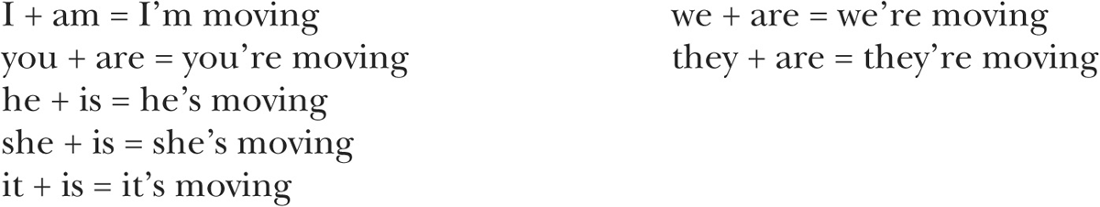

exercise 3-3

Use the pronoun and verb given to create a sentence that contains a contraction.
EXAMPLE: I, follow
I’m following in my parents’ footsteps.
1. He, pay
2. It, hail
3. We, meet
4. They, lose
5. She, wait
6. You, carry
7. I, wear
8. We, read
9. She, call
10. He, sell
11. They, stay
12. I, assist

Forming Negatives
To make a present progressive verb negative, place not after the auxiliary verb.

exercise 3-4

Make each of the following sentences negative.
EXAMPLE: We are ordering pizza for dinner tonight.
We are not ordering pizza for dinner tonight.
1. I am buying a new car tomorrow.
2. She is studying.
3. We are leaving soon.
4. They are coming with us.
5. Carla is living with her parents.
6. I am cooking dinner tonight.
7. The band is performing tonight.
8. My mother is visiting this weekend.
9. They are sleeping.
10. We are going to the park today.
11. They are fixing the road.
12. She is quitting her job.

Forming Contractions: Pronouns with Am Not, Is Not, and Are Not
The following contractions can be used in conversation and informal writing:
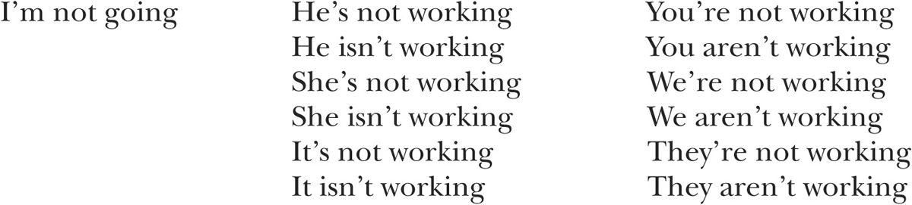

exercise 3-5

Rewrite the sentences in exercise 3-4 using contractions.
1.
2.
3.
4.
5.
6.
7.
8.
9.
10.
11.
12.

Forming Yes/No Questions
To form yes/no questions, begin the question with the auxiliary verb be. After the auxiliary verb, place the subject and the -ing form of the main verb.

Statement: Prices are falling.
Yes/no question: Are prices falling?

exercise 3-6

Rewrite the following statements as yes/no questions.
EXAMPLE: You are finishing your paper.
Are you finishing your paper?
1. The mail carrier is delivering a package to our house.
2. The boat is sinking.
3. They are causing trouble.
4. He is worrying about his course grade.
5. Helen is publishing her autobiography.
6. The teacher is inviting everyone in class to a party.
7. The committee is announcing the winner of the contest today.
8. The engineer is explaining the process.
9. Mandy is singing at her sister’s wedding.
10. The company is expanding.
11. Phil is arranging the conference.
12. The police are accusing him of the crime.

Forming Wh-Questions
In Wh-questions, when the question word is the subject of the sentence, the form of the question is similar to the form of a statement.

Statement: Someone is talking on the telephone.
Wh-question: Who is talking on the telephone?
When the question word is any other part of the sentence, the auxiliary verb be comes after the question word and is followed by the subject and the -ing form of the main verb.

Statement: They are going to the store.
Wh-question: Where are they going?

Statement: He is writing a play.
Wh-question: What is he writing?

exercise 3-7

Complete the following questions based on the statements provided.
EXAMPLE: We are leaving in the morning.
When are we leaving?
1. They are eating pasta salad.
What
2. Fran is coming along.
Who
3. We are watching the soccer game on television tonight.
What
4. She is showing them some of her new paintings.
What
5. You are meeting the director.
Whom
(Who may be used instead of whom in conversation and informal writing.)
6. They are wearing special clothes because it is a holiday.
Why
7. He is hoping for a new job.
What
8. Something strange is happening.
What
9. Alex and Terry are playing Scrabble.
What
10. They are moving to Mexico.
Where
11. Somebody is staring at us.
Who
12. Venus Williams is winning.
Who

Unit 4 Present Perfect
Use the present perfect when you want to refer to a situation that originated in the past but continues into the present or to refer to a past experience that has current relevance.
PAST SITUATION CONTINUING INTO THE PRESENT: I have lived in Dallas for six years.
PAST EXPERIENCE WITH CURRENT RELEVANCE: We have traveled to Alaska three times.
For an experience to be relevant, it is usually related to a possible future experience. In the example “We have traveled to Alaska three times,” the speaker may be considering another trip. The present perfect is often used in job interviews when an employer asks a prospective employee about his or her experience: “Have you ever driven a large vehicle?” “Have you ever used a cash register?”
The present perfect consists of the auxiliary verb have and the perfect/passive form of the main verb. The auxiliary verb is marked for tense. The perfect/passive verb form is used to indicate either the perfect aspect or the passive voice. (The passive voice will be discussed in Part IV.) The perfect/passive form for regular verbs consists of the base form of the verb and the ending -ed.
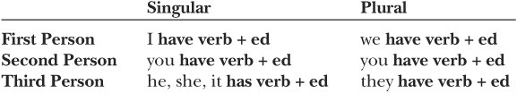
When a one-syllable word or a word with a stressed final syllable ends in a single consonant sound, double the last letter before adding -ed.
One-syllable word: pet → petted
Word ending in a stressed syllable: admit → admitted
BUT sew → sewed [This word ends in a vowel sound.]
The present/passive forms of irregular verbs can be found in the appendix.
The following are common irregular verb patterns:

• Pattern 1: The final d becomes a t.
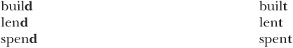
• Pattern 2: A -d or -t suffix is added. The vowel changes.
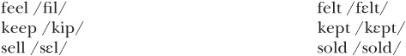
• Pattern 3: An -n or -en suffix is added.
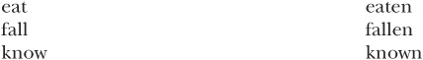
Sometimes the vowel changes.
• Pattern 4: Just the vowel changes.
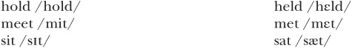
• Pattern 5: The base form and perfect/passive form are the same.
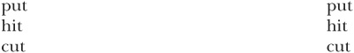

exercise 4-1

Complete each sentence with the present perfect form of the verb in parentheses. If you are unsure of the perfect/passive form, check the chart in the appendix.
1. Pat and Tom _____________ (build) two houses this summer.
2. I _____________(eat) already.
3. His parents _____________ (lend) him some money.
4. We _____________ (speak) to the director about our concerns.
5. The company’s stock _____________ (fall).
6. You _____________ (know) me for a long time.
7. They _____________(sell) their house.
8. It _____________ (rain) every day for a week.
9. I _____________(keep) your secret.
10. He _____________ (spend) too much money this month.
11. The bride and groom _____________(cut) the wedding cake.

Forming Contractions: Pronouns with the Auxiliary Verb Have
Contractions are often formed by combining a pronoun and the auxiliary verb have. You will often hear these contractions in conversation or see them in informal writing, but you will rarely find them used in formal contexts.
Notice that an apostrophe indicates the omission of the letters h and a:
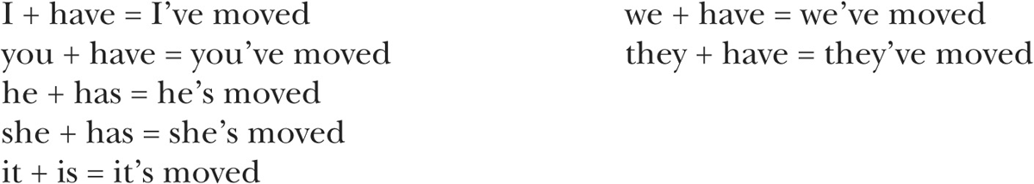

exercise 4-2

Use the pronoun and verb given to create a sentence that contains a contraction.
EXAMPLE: I, ask
I’ve asked too many questions.
1. He, rent
an apartment for the summer.
2. It, work
until now.
3. We, be
friends for a long time.
4. They, lose
another game.
5. She, wait
a long time.
6. You, reach
your goal.
7. I, apply
for a new job.
8. We, develop
some new software.
9. She, ignore
our advice.
10 He, find
his keys.
11. They, go
home.
12. I, forget
my books.

Forming Negatives
To make a present perfect verb negative, place not after the auxiliary verb.

exercise 4-3

Make each of the following sentences negative.
EXAMPLE: We have calculated the cost.
We have not calculated the cost.
1. They have chosen a location for the conference.
2. She has completed her work.
3. We have studied our options.
4. I have received my test results.
5. You have mentioned his name before.
6. He has reviewed the plans.
7. It has disappeared.

Forming Contractions: Hasn’t and Haven’t
The following contractions can be used in conversation and informal writing:
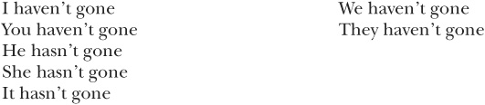

exercise 4-4

Rewrite the sentences in exercise 4-3 using contractions.
1.
2.
3.
4.
5.
6.
7.

Forming Yes/No Questions
To form yes/no questions, begin the question with the auxiliary verb have. After the auxiliary verb, place the subject and the perfect/passive form of the main verb.

Statement: His personality has changed.
Yes/no question: Has his personality changed?

exercise 4-5
Rewrite the following statements as yes/no questions.
EXAMPLE: She has followed the directions.
Has she followed the directions?
1. You have put the dishes away.
2. They have offered her a new job.
3. We have received good news.
4. He has checked the oil in the car.
5. Jackson has obtained a driver’s license.
6. The new student has arrived.
7. Jeanette has responded to our message.
8. The archaeologists have discovered new fossils.
9. You have made your lunch.
10. The business has expanded.
11. Sarah has arranged the meeting.
12. The program has been successful.

Forming Wh- Questions
In Wh-questions, when the question word is the subject of the sentence, the form of the question is similar to the form of a statement.

Statement: Michael has represented us.
Wh-question: Who has represented us?
When the question word is any other part of the sentence, the auxiliary verb have comes after the question word and is followed by the subject and the perfect/passive form of the main verb.

Statement: They have collected old cars.
Wh--question: What have they collected?

Statement: You have moved three times.
Wh--question: How many times have you moved?

exercise 4-6

Complete the following questions based on the statements provided.
EXAMPLE: Scott has prevented an accident.
Who has prevented an accident?
1. They have given computers to charities.
What
2. The governor has appeared on television.
Who
3. She has missed three games.
How many games
4. Dan has passed the first part of the test.
Who
5. You have read three of his novels.
How many of his novels
6. Les has painted his house green.
What color
7. She has sung at the White House.
Who
8. Something unbelievable has happened.
What
9. She has influenced your decision.
Who
10. He has taken all of the required courses.
Which courses
11. You have taught English for fifteen years.
How many years
12. They have invited everyone in class to the party.
Whom
(Who may be used instead of whom in conversation and informal writing.)
Unit 5 Present Perfect Progressive
When you want to refer to an action, a state, or an event that originated in the past but is still ongoing or incomplete, use the present perfect progressive.
ONGOING STATE: I have been living on a ship for three months.
INCOMPLETE ACTION: We have been organizing this trip since May.
The present perfect progressive consists of two auxiliary verbs, have and be, and the -ing form of the main verb. The auxiliary verb have comes first, and it is marked for tense. Next comes the perfect/passive form of the verb be—been. The final element of the present perfect progressive is the -ing form of the main verb.
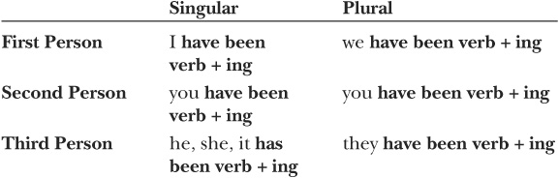

exercise 5-1

Complete each sentence with the present perfect progressive form of the verb in parentheses.
1. My knee (hurt) for a week.
2. The new policy (cause) some confusion.
3. Janice (exercise) for an hour.
4. I (drink) a lot of coffee today.
5. He (worry) too much.
6. She (earn) good grades in all her classes.
7. Her parents (pay) for her apartment.
8. We (follow) your instructions.
9. We (sit) here too long.
10. I (apply) for scholarships.
11. They (help) each other.
12. Temperatures (rise).

Forming Contractions: Pronouns with the Auxiliary Verb Have
Contractions can be formed by combining a pronoun and the auxiliary verb have. You will often hear these contractions in conversation or see them in informal writing, but you will rarely find them used in formal contexts.
Notice that an apostrophe indicates the omission of the letters h and a:
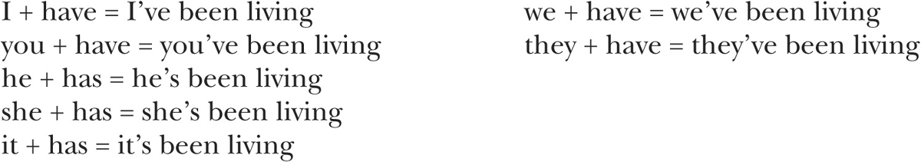

exercise 5-2

Use the pronoun and verb given to create a sentence that contains a contraction.
EXAMPLE: We, hope
We’ve been hoping for better weather.
1. He, expect
a phone call.
2. It, change
day by day.
3. We, develop
a new game.
4. They, check
their e-mail every day.
5. She, explore
her new home.
6. You, complain
about your sore back all day.
7. I, calculate
my income tax.

Forming Negatives
To make a present perfect progressive verb negative, place not after the auxiliary verb have.

exercise 5-3

Complete each of the following sentences using the subject and verb provided.
EXAMPLE: We, fall, not
We have not been falling behind in our work.
1. He, ignore, not
the evidence.
2. It, improve, not
much.
3. We, commute, not
together this year.
4. They, buy, not
much lately.
5. She, do, not
her work.
6. You, finish, not
your projects on time.
7. I, ride, not
the bus to school.

Forming Contractions: Hasn’t and Haven’t
The following contractions can be used in conversation and informal writing:
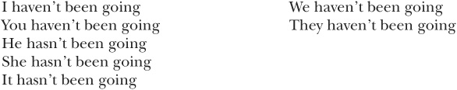

exercise 5-4

Rewrite the sentences in exercise 5-3 using contractions.
1.
2.
3.
4.
5.
6.
7.

Forming Yes/No Questions
To form yes/no questions, begin the question with the auxiliary verb have. After a tensed form of have, place the subject, the perfect/passive form of the auxiliary verb be (been), and the -ing form of the main verb.

Statement: You have been tiring easily.
Yes/no question: Have you been tiring easily?

exercise 5-5

Rewrite the following statements as yes/no questions.
EXAMPLE: She has been using the new database.
Has she been using the new database’?
1. You have been paying all your bills on time.
2. The noise has been bothering them.
3. Traffic has been moving slowly.
4. She has been waiting a long time.
5. They have been reducing the number of accidents.
6. The suspect has been lying.
7. You have been reading an interesting novel.
8. The government has been allowing journalists into the country.
9. She has been keeping good records.
10. They have been considering the proposal.
11. He has been staying close to home.
12. She has been making progress.

Forming Wh-Questions
In Wh-questions, when the question word is the subject of the sentence, the form of the question is similar to the form of a statement.

Statement: Brad Omans has been reporting the news.
Wh-question: Who has been reporting the news?
When the question word is any other part of the sentence, the auxiliary verb have comes after the question word and is followed by the subject, the perfect/passive form of the auxiliary verb be (been), and the -ing form of the main verb.

Statement: Many people have been going to the carnival.
Wh-question: Where have many people been going?

Statement: You have been looking at something.
Wh-question: What have you been looking at?

exercise 5-6
Complete the following questions based on the statements provided.
EXAMPLE: Barbara has been studying at night.
When has Barbara been studying?
1. Paula has been traveling all over Asia.
Where
2. He has been living in Miami for five years.
How long
3. They have been searching for their lost dog.
What
4. My grandfather has been watching the children.
Who
5. They have been going to the Virgin Islands every spring.
How often
6. The guide has been arranging a special tour of the ruins.
What
7. Pei-Hsuan has been taking notes.
Who
8. You have been attending the university since 2002.
How long
9. They have been planning a surprise party for Marta.
What
10. He has been talking about his new design.
What
11. You have been feeling better lately.
How
12. She has been standing there for two hours.
How long
Summary of Tense-Aspect Combinations

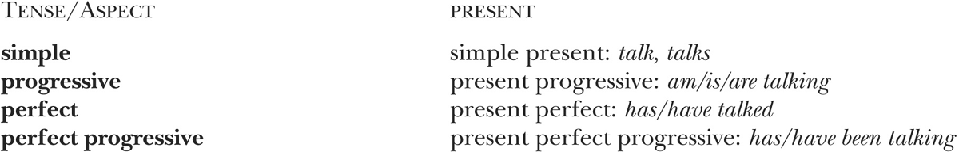

PART II
THE PAST TENSE
Verbs in the past tense occur in four forms, each signaling a different aspect. (Aspect is explained in the Introduction.) These forms convey information about actions, states, or events that are remote in the speaker’s mind. The past tense most often refers to past time.
SIMPLE PAST: I waited patiently.
PAST PROGRESSIVE: I was waiting for a bus.
PAST PERFECT: I had waited long enough.
PAST PERFECT PROGRESSIVE: I had been waiting for three hours.
In the following units, you will learn about these verb forms and the reasons for using them.

Unit 6 Simple Past
When you refer to past or completed actions, states, or events, use simple past verb forms.
COMPLETED ACTION: We drove three hundred miles.
PAST STATE: They seemed uneasy.
PAST EVENT: The schedule changed.
You can also use the simple past to refer to a hypothetical action, state, or event.
HYPOTHETICAL ACTION: If you joined our team, we could win the championship.
Sentences such as this one will be discussed in more detail in Part IV.
The simple past for regular verbs consists of the verb and the ending -ed.
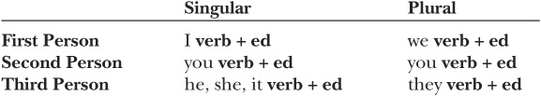
For regular verbs, the simple past form and the perfect/passive form (see pages 29-30) are the same.
When a one-syllable word or a word with a stressed final syllable ends in a single consonant sound, double the last letter before adding -ed.
One-syllable word: plan → planned
Word ending in a stressed syllable: occur → occurred
BUT row → rowed [This word ends in a vowel sound.]
Irregular verbs have a variety of simple past forms, which can be found in the appendix.
The following are common irregular verb patterns. Some of these irregular simple past forms are the same as the perfect/passive forms.
• Pattern 1: The final d becomes a t. (Same as perfect/passive)
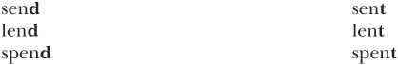
• Pattern 2: A -d or -t suffix is added. The vowel changes. (Same as perfect/passive)
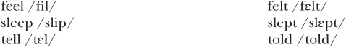
• Pattern 3a: The vowel changes. (Different from perfect/passive)
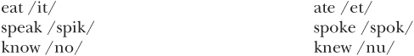
• Pattern 3b: The vowel changes. (Same as perfect/passive)
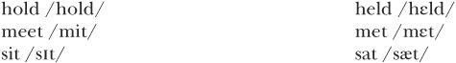
• Pattern 4: The base form and the simple past form are the same. (Same as perfect/passive)
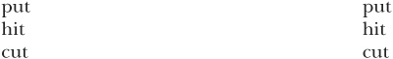

exercise 6-1

Complete each sentence with the simple past form of the verb in parentheses. The first five verbs are regular; the second five are irregular.
1. We_____________ (work) hard all day.
2. The fans_____________ (wait) in line for tickets.
3. I_____________(remember) her face.
4. He_____________(need) a computer upgrade.
5. She_____________ (miss) class now and then.
6. They_____________ (sell) some of their land.
7. Chen_____________ (go) to work at 3:00.
8. Tim and Andrea first _____________ (meet) at a mutual friend’s party.
9. I accidentally _____________ (cut) my finger.
10. Everyone at the party _____________ (wear) a costume.

exercise 6-2

Complete each sentence with either the simple past or the present perfect. Remember that the simple past indicates completion, while the present perfect indicates continued relevance. If you need help, review pages 29–30 and 47.
1. Joe and Donna _____________ (live) here in the 1990s.
2. Joe and Donna _____________ (live) here since the 1990s.
3. Maria and I _____________ (study) together for two years. We meet in the library every Wednesday night at 7:00.
4. Maria and I _____________ (study) together last year.
5. We_____________(travel) to London in April.
6. We_____________ (travel) to many countries, but this year we’re staying home.
7. I _____________(work) for Safeway since May.
8. I _____________(work) for Safeway in 2003.
9. He _____________ (build) many houses. He is currently building one on Madison Street.
10. He _____________ (build) a house for his sister.

Forming Negatives
To make a verb negative, add the auxiliary verb did, which is the simple past form of do, and the word not before the main verb.
did not believe

exercise 6-3

Make each of the following sentences negative.
EXAMPLE: I made a mistake.
I did not make a mistake.
1. He came to work on time.
2. My roommate liked the movie.
3. She understood the problem.
4. We took a wrong turn.
5. The students needed help with the homework.
6. The driver blamed me for the accident.
7. I listened to the directions.
8. She earned a degree in economics.
9. He calculated the taxes.
10. They complained about the weather.

Forming Contractions
In English, verbs are often combined with other words to form contractions. These shortened forms include an apostrophe (’) to indicate missing letters. It is important to learn contractions because you will often hear them in conversation or see them in informal writing. Formal writing, though, rarely contains contractions.
The auxiliary verb did is often combined with not to form a contraction. Notice that an apostrophe indicates that the letter o is omitted:
did + not = didn’t

exercise 6-4

Rewrite the sentences you wrote in exercise 6-3 using contractions.
1.
2.
3.
4.
5.
6.
7.
8.
9.
10.

Forming Yes/No Questions
To form questions that can be answered yes or no (yes/no questions), begin the question with the auxiliary verb did. After the auxiliary verb, place the subject and the main verb.

Statement: He took the bus to work.
Yes/no question: Did he take the bus to work?

exercise 6-5

Rewrite the following statements as yes/no questions.
EXAMPLE: You finished your application letter.
Did you finish your application letter?
1. They elected a new president.
2. She delivered the report.
3. You expected us earlier.
4. Tho passed his driver’s test.
5. The committee explored the issues.
6. He explained the problem.
7. The director had an appointment at 3:00.
8. You forgot the map.
9. The bank lent him some money.
10. They offered him a job.

Forming Wh-Questions
Wh-questions are used to elicit specific pieces of information. They usually begin with what, who, why, where, when, how, or combinations such as how much, how many, and how often. When the question word is the subject of the sentence, the form of the question is similar to the form of a statement.

Statement: Someone knocked on the door.
Wh-question: Who knocked at the door?
When the question word is any other part of the sentence, the auxiliary verb did comes after the question word and is followed by the subject and the main verb.

Statement: She bought a new cell phone.
Wh-question: What did she buy?

Statement: They left last night.
Wh-question: When did they leave?

exercise 6-6

Complete the following questions based on the statements provided.
EXAMPLE: He found the missing document on the top shelf.
Where did he find the missing document?
1. Toni Morrison wrote Beloved.
Who
2. Patty won the contest.
Who
3. He turned left.
Which way
4. They traveled to four different countries.
How many countries
5. You taught biology for thirty years.
How long
6. The repair cost $35.00.
How much
7. They stayed at the party until midnight.
How long
8. She ran fifteen miles.
How far
9. They moved to Hong Kong.
Where
10. They climbed to the summit.
How far

Unit 7 Be Verb Forms
The verb be has two different forms in the simple past: was and were.
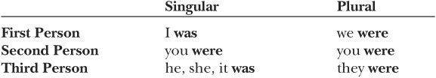

exercise 7-1

Complete each sentence with the simple past form of the verb be.
1. The test _____________ difficult.
2. You _____________ right.
3. They _____________ envious.
4. Bill _____________ ill yesterday.
5. The news _____________ good.
6. We _____________ embarrassed.
7. I _____________ ready for the exam.
8. The keys _____________ in the car.
9. It _____________ fun.
10. The house _____________ old and decrepit.
The word there is often used with the verb be to acknowledge the existence of someone or something. The form of the verb is based on the subject that follows it.

Singular subject: There was a storm last night.
Plural subject: There were twelve people in the cast.

exercise 7-2

Circle the verb that agrees in number with the subject that follows it.
1. There was/were a parade yesterday.
2. There was/were many celebrities at the rally.
3. There was/were a lot of traffic.
4. There was/were pizza for everyone.
5. There was/were several buildings in need of repair.
6. There was/were no more tickets left.
7. There was/were a four-hour delay.
8. There was/were an empty seat in the back row.
9. There was/were many tourists at this year’s festival.
10. There was/were a nice breeze earlier this morning.

Forming Negatives
To make the verb be negative, just add not.

Forming Contractions
In conversation and informal writing, you can use contractions.

exercise 7-3

Complete the sentences using either wasn’t or weren’t.
1. They _____________ at home yesterday.
2. I _____________ prepared for such a long trip.
3. There _____________ any leftovers.
4. Carlos _____________ at work on Tuesday.
5. We _____________ pleased with the report.
6. There _____________ much time left.
7. Jenny and Sik _____________ in class.
8. The lights _____________ on.
9. You _____________ at the party.
10. The accident _____________ serious.

Forming Yes/No Questions
To form yes/no questions, begin the question with a form of the verb be and place the subject after it.

Statement: John was late.
Yes/no question: Was John late?

Statement: They were surprised.
Yes/no question: Were they surprised?
To form yes/no questions with there, place there after the be verb.

Statement: There was a message for Natalie on the answering machine.
Yes/no question: Was there a message for Natalie on the answering machine?

exercise 7-4

Rewrite the following statements as questions.
EXAMPLE: He was sick last week.
Was he sick last week?
1. The concert was in the park.
2. The road was under construction.
3. Everyone was on time.
4. The textbooks were expensive.
5. The job was stressful.
6. The program was a success.
7. There were many apartments for rent.
8. The parking lot was full.
9. The tickets were free.
10. The computer was on.

Forming Wh-Questions
To form wh-questions, place the be verb after the question word. When the question word is the subject of the sentence, the form of the question is similar to the form of a statement.

Statement: Cindy was the winner.
Wh-question: Who was the winner?
When the question word is any other part of the sentence, the subject follows the be verb.

Statement: They were in Mexico last week.
Wh-question: Where were they last week?

Statement: She was in the office on Tuesday.
Wh-question: When was she in the office?

exercise 7-5

Complete the following questions based on the statements provided.
EXAMPLE: The weather was good.
How was the weather?
1. In 1980, Jimmy Carter was the president of the United States.
Who
2. The trip was long and arduous.
How
3. His grandparents were from Brazil.
Where
4. They were in the library.
Where
5. The field trip was on Wednesday.
When
6. The gym was open four hours on Sunday.
How long
7. CDs and DVDs were on sale.
What items
8. The traffic was bad.
How
9. Seth was there.
Who
10. The movie was two hours long.
How long

Unit 8 Past Progressive (Be Verb + -ing)
When you refer to a past action, state, or event that is incomplete or in progress, use the past progressive.
PAST ACTION: In 2002, I was working for a large company in Houston.
PAST STATE: I was feeling fine ten minutes ago.
PAST EVENT: Something strange was happening.
A specific time reference is often used with the past progressive. This reference is generally a prepositional phrase or another clause with a simple-past verb form.
PREPOSITIONAL PHRASE: By 5:00, all the participants were packing their bags.
CLAUSE: While I was preparing breakfast, I heard the news on the radio.
When you want to indicate two simultaneous ongoing actions, use the past progressive for both.
SIMULTANEOUS ACTIONS: While I was preparing breakfast, I was listening to the news.
The past progressive consists of the auxiliary verb be and the -ing form of the main verb. The auxiliary verb is marked for tense.
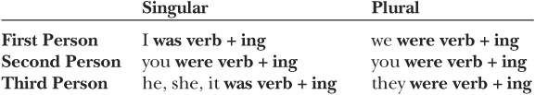
When a one-syllable word or a word with a stressed final syllable ends in a single consonant sound, double the last letter before adding -ing.
One-syllable word: swim → swimming
Word ending in a stressed syllable: permit → permitting
BUT show → showing [This word ends in a vowel sound.]
When a word ends with the letter e, drop the e before adding -ing.

exercise 8-1

Complete each sentence with the past progressive form of the verb in parentheses.
1. The customer(be) rude.
2. The telephone(ring) all day long.
3. While I(wait), I(dream) of distant places.
4. When you visited last year, they (live) in a different apartment.
5. My roommate (take) a nap while I_________(study).
6. She(put) on her coat when I walked in.
7. Someone (knock) at the door just as I (get) out of bed.
8. It(rain) a few minutes ago.
9. They saw an accident while they(go) to work.
10. We found old books and toys when we(clean).

exercise 8-2

The verb forms in the following sentences are either simple past or past progressive. Decide whether the verb in each sentence indicates a complete action or an ongoing past action. If you need help, review pages 47–48 and 61.
1. He played the piano beautifully.
2. He was playing the piano as the guests were arriving.
3. I was cooking dinner when I remembered his name.
4. I cooked dinner for everyone.
5. They were shopping for a new lamp, but they couldn’t find a nice one.
6. They shopped for a lamp until they found a nice one.
7. When we lived in the suburbs, we commuted to work.
8. While we were commuting to work, we talked about our families.
9. She was working for Apex Law Firm when she received a new job offer.
10. She worked for Apex Law Firm from 1999 to 2002.

Forming Negatives
To make a past progressive verb negative, place not after the auxiliary verb.

exercise 8-3

Make each of the following sentences negative.
EXAMPLE: We were visiting our relatives.
We were not visiting our relatives.
1. He was attending a conference.
2. They were laughing.
3. I was complaining about the work.
4. She was helping us.
5. Ted was studying last night.
6. They were paying attention.
7. I was talking to myself.
8. You were speaking loud enough.
9. They were doing their homework.
10. We were trying hard.

Forming Contractions
Contractions are often formed by combining the auxiliary verb be and not. You will often hear these contractions in conversation or see them in informal writing, but you will rarely find them used in formal contexts.
Notice that an apostrophe indicates that the letter o is omitted:
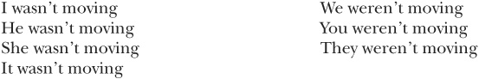

exercise 8-4

Rewrite the sentences in exercise 8-3 using contractions.
1.
2.
3.
4.
5.
6.
7.
8.
9.
10.

Forming Yes/No Questions
To form yes/no questions, begin the question with the auxiliary verb be. After the auxiliary verb, place the subject and the -ing form of the main verb.

Statement: Prices were dropping.
Yes/no question: Were prices dropping?

exercise 8-5

Rewrite the following statements as yes/no questions.
EXAMPLE: You were singing to yourself.
Were you singing to yourself?
1. The band was giving a free concert.
2. The light was blinking on and off.
3. You were watching the championship on television.
4. They were being careful.
5. It was snowing all day.
6. Gabe and Don were singing together.
7. They were closing the store.
8. The companies were considering a merger.
9. They were recycling most of the waste products.
10. As young children, they were always getting into trouble.

Forming Wh-Questions
In wh-questions, when the question word is the subject of the sentence, the form of the question is similar to the form of a statement.

Statement: Ken was demanding your attention.
Wh-question: Who was demanding your attention?
When the question word is any other part of the sentence, the auxiliary verb be comes after the question word and is followed by the subject and the -ing form of the main verb.

Statement: They were going to church.
Wh-question: Where were they going?

Statement: He was playing solitaire.
Wh-question: What was he playing?

exercise 8-6

Complete the following questions based on the statements provided.
EXAMPLE: The assistant was making travel arrangements.
Who was making travel arrangements?
1. They were protesting in front of the post office.
Where
2. Carmen was using this computer.
Who
3. You were watching a funny movie on television last night.
What
4. The committee was discussing the new plan.
What
5. The noise was bothering them.
What
6. Lev was spreading rumors.
Who
7. He was working at McDonald’s.
Where
8. She was driving seventy-five mph.
How fast
9. He was reading a newspaper during class today.
What
10. They were standing in front of city hall.
Where

Unit 9 Past Perfect
Use the past perfect when you want to refer to a past action, state, or event that occurred prior to another time in the past. The more recent past time may be expressed as a prepositional phrase or as a clause in which another action, state, or event is mentioned.
PAST ACTION BEFORE PAST TIME: They had finished the project by Friday.
PAST STATE BEFORE PAST ACTION: He had been depressed before he went on vacation.
You can also use the past perfect to refer to a hypothetical action, state, or event.
HYPOTHETICAL ACTION: If they had come earlier, they would have received free tickets.
Sentences such as this one will be discussed in more detail in Part IV.
The past perfect consists of the auxiliary verb have and the perfect/passive form of the main verb. The auxiliary verb is marked for past tense. The perfect/passive verb form is used to indicate either the perfect aspect or the passive voice. (The passive voice will be discussed in Part IV.) The perfect/passive form for regular verbs consists of the base form of the verb and the ending -ed.
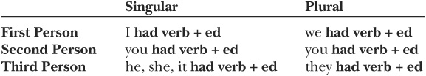
When a one-syllable word or a word with a stressed final syllable ends in a single consonant sound, double the last letter before adding -ed.
One-syllable word: pat → patted
Word ending in a stressed syllable: occur → occurred
BUT tow → towed [This word ends in a vowel sound.]
The present/passive forms of irregular verbs can be found in the appendix.
If you would like to see the common patterns that irregular verbs follow, see those listed for the present perfect on pages 29-30.

exercise 9-1

Complete each sentence with the past perfect form of the verb in parentheses. If you need help with irregular verb forms, check the appendix.
1. Before 2001, they _____________ (attend) college in Philadelphia.
2. After we _____________ (hold) a meeting, we announced our decision.
3. They _____________ (sell) most of their furniture before they moved.
4. The employees _____________ (meet) the new director already.
5. I _____________ (feel) uneasy before I gave my speech.
6. He _____________ (hit) twenty home runs before the All-Star Game.
7. We _____________ (sit) down right before the concert began.
8. She _____________ (run) three marathons by the age of twenty.
9. It _____________ (snow) so much that school was canceled.
10. She _____________ (be) there so often that everyone knew her.

exercise 9-2

Using the verbs in parentheses, complete each sentence with either the simple past or the past perfect.
1. The taxi _____________ (arrive) after he _____________(left).
2. After we _____________ (finish) the dishes, we _____________ (go) for a walk.
3. The teacher __________ (assign) twenty problems, but most students _________(complete) only fifteen of them.
4. She _____________ (be) tired because she _____________ (work) late the night before.
5. He _____________(wear) the ring that his grandfather _____________ (give) him.
6. I _____________ (revise) a paper that I _____________ (write) a year ago.
7. She _____________ (knock) on the door before she _____________ (enter).
8. All of a sudden we _____________ (know) that we _____________ (take) the wrong exit off the freeway.
9. He _____________ (read) aloud from a new book he _____________ (receive) as a gift.
10. They _____________ (celebrate) because they _____________ (pass) all their classes.

Forming Negatives
To make a past perfect verb negative, place not after the auxiliary verb,
had not gone

exercise 9-3

Complete each of the following sentences with a negative form of the past perfect. Use the subject and verb provided.
EXAMPLE: He, finish
It was midnight, and he had not finished his paper.
1. They, meet
before.
2. It, change
Because color, no one could see it.
3. We, consider
all the possibilities.
4. He, want
help from us.
5. She, drive
to the party.
6. You, speak
English before you came here.
7. I, sent
my application in on time.

Forming Contractions
Contractions are often formed by combining pronouns and the auxiliary verb had or by combining the auxiliary verb had and not. You will often hear these contractions in conversation or see them in informal writing, but you will rarely find them used in formal contexts.
Notice that an apostrophe indicates that at least one letter is omitted:
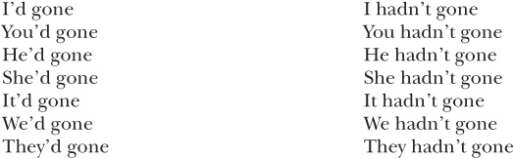

exercise 9-4

Rewrite each sentence in exercise 9-3 using a contraction. First, write a positive sentence; then write a negative sentence (with not).
EXAMPLE: He, finish
It was midnight, and he’d finished his paper.
It was midnight, and he hadn’t finished his paper.
1.
2.
3.
4.
5.
6.
7.

Forming Yes/No Questions
To form yes/no questions, begin the question with the auxiliary verb had. After the auxiliary verb, place the subject and the perfect/passive form of the main verb.

Statement: She had taught in Mexico before she moved here.
Yes/no question: Had she taught in Mexico before she moved here?

exercise 9-5

Rewrite the following statements as yes/no questions.
EXAMPLE: He hadn’t known about the bad roads before he left.
Hadn’t he known about the bad roads before he left?
1. She hadn’t called before she arrived.
2. They hadn’t obtained permission before they started the experiment.
3. Pat had won the first race before he ran the second race.
4. They had closed the road.
5. They had canceled the game without prior notice.

Forming Wh-Questions
In Wh-questions, when the question word is the subject of the sentence, the form of the question is similar to the form of a statement.

Statement: Jackie had not studied English before coming to the United States.
Wh-question: Who had not studied English before coming to the United States?
When the question word is any other part of the sentence, the auxiliary verb had comes after the question word and is followed by the subject and the perfect/passive form of the main verb.

Statement: He had walked two miles before he realized his mistake.
Wh-question: How far had he walked before he realized his mistake?

exercise 9-6
Complete the following questions based on the statements provided.
EXAMPLE: Sharon had worked in Taiwan before she moved to Kuala Lumpur.
Where had Sharon worked before she moved to Kuala Lumpur?
1. Peggy and Mel had received job offers before they graduated.
Who
2. Peter had broken six track records by the age of eighteen.
How many track records
3. She had taught English for ten years before she went to law school.
How long
4. He had arrived at the gate a minute before the flight attendant closed the door to the plane.
When
5. They had dated for two years before they got married.
How long
Unit 10 Past Perfect Progressive
When you want to refer to an action, a state, or an event that originated prior to another time in the past but is still ongoing or incomplete, use the past perfect progressive.
ONGOING STATE: I had been having frequent headaches, so I decided to visit a doctor.
INCOMPLETE ACTION: We had been making plans when someone interrupted us.
You can also use the past perfect progressive to refer to a hypothetical action or event.
HYPOTHETICAL ACTION: If they had been paying attention, they would have found the clues.
Sentences such as this one will be discussed in more detail in Part IV.
The past perfect progressive consists of two auxiliary verbs, have and be, and the -ing form of the main verb. The auxiliary verb had comes first, and it is marked for tense.
Next comes the perfect/passive form of the verb be—been. The final element of the past perfect progressive is the -ing form of the main verb.
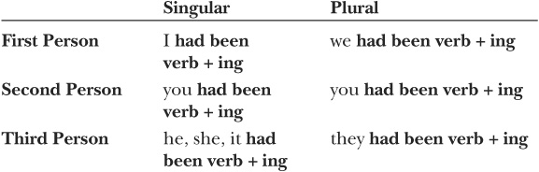

exercise 10-1
Complete each sentence with the past perfect progressive form of the verb in parentheses.
1. I (work) ten-hour days, so I was very tired.
2. We (discuss) that issue when the supervisor walked in.
3. They (study) English since they came in 2001.
4. The company’s profits (increase) until they dropped in December.
5. They (play) soccer together for years.
6. It (rain) all day, so the game was postponed.
7. The children (watch) television before we arrived.
8. He (write) newspaper editorials for twenty years.
9. Sally (study) since 6:00 A.M.
10. I (work) for the telephone company before I came here.

Forming Negatives
To make a past perfect progressive verb negative, place not after the auxiliary verb had.
had not been going

exercise 10-2

Complete each of the following sentences with the negative form of the past perfect progressive. Use the subject and verb provided.
EXAMPLE: We, expect, not
We had not been expecting your call.
1. The supervisor, assign, not
much work lately.
2. The weather, improve, not
, so we returned home.
3. Jodi and I, follow, not
his directions.
4. They, check, not
the oil in their car frequently enough.
5. She, ignore, not
the phone messages.
6. You, get, not
to work on time.
7. I, exercise, not
, so I was feeling sluggish.

Forming Contractions
Contractions are often formed by combining pronouns and the auxiliary verb had or by combining the auxiliary verb had and not. You will often hear these contractions in conversation or see them in informal writing, but you will rarely find them used in formal contexts.
Notice that an apostrophe indicates that at least one letter is omitted:
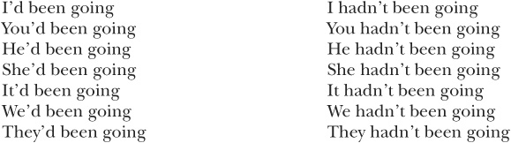

exercise 10-3

Use the pronoun and verb given to create a sentence that contains a contraction. If not is also given, use a negative contraction.
EXAMPLE: We, hope
We’d been hoping for a nice day.
1. He, expect, not
a phone call.
2. It, change
slowly.
3. We, hope
for good news.
4. They, look, not
in the right places.
5. She, lie
on the couch when the doorbell rang.
6. You, joke, not
about the possible danger.
7. I, think
about you when your letter arrived.

Forming Yes/No Questions
To form yes/no questions, begin the question with the auxiliary verb have. After a tensed form of have {had), place the subject, the perfect/passive form of the auxiliary verb be (been), and the -ing form of the main verb.

Statement: She had been doing all her work.
Yes/no question: Had she been doing all her work?

exercise 10-4

Rewrite the following statements as yes/no questions.
EXAMPLE: The administration had been putting pressure on the employees.
Had the administration been putting pressure on the employees?
1. You had been working too hard.
2. He had been living by himself.
3. She had been talking too loudly.
4. They had been waiting a long time.
5. The suspect had been telling the truth.

Forming Wh-Questions
In wh-questions, when the question word is the subject of the sentence, the form of the question is similar to the form of a statement.

Statement: Joseph had been driving when the accident happened.
Wh-question: Who had been driving when the accident happened?
When the question word is any other part of the sentence, the auxiliary verb had comes after the question word and is followed by the subject, the auxiliary verb been, and the -ing form of the main verb.

Statement: She had been living in St. Louis at the time.
Wh-question: Where had she been living at the time?

exercise 10-5

Complete the following questions based on the statements provided.
EXAMPLE: The band had been playing together for five years.
How long had the band been playing together?
1. Michelle had been making the arrangements.
Who
2. He had been thinking about moving for the last few months.
How long
3. They had been using my old computer before the new shipment arrived.
What
4. Vladimir had been leading the discussion when the argument started.
Who
5. They had been working on the project since June.
How long
Summary of Tense-Aspect Combinations

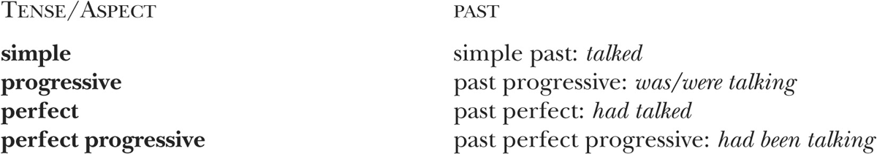

PART III
THE FUTURE TENSE
Verbs in the future tense occur in four forms, each signaling a different aspect. (Aspect is explained in the Introduction.) Each of these forms can be used to predict future actions, states, or events.
SIMPLE FUTURE: I will work on my project tomorrow.
FUTURE PROGRESSIVE: I will be working for my father next year.
FUTURE PERFECT: By the end of the winter, I will have worked here for five years.
FUTURE PERFECT PROGRESSIVE: On Monday, I will have been working with you for ten years.
In the following units, you will learn about these verb forms and the reasons for using them.

Unit 11 Simple Future
When you are referring to a future action, state, or event, use the simple future.
FUTURE ACTION: We will take our final exam on Friday.
FUTURE STATE: They will be late.
FUTURE EVENT: The weather will improve.
To form the simple future for both regular and irregular verbs, place the modal auxiliary verb will before the base form of the verb.
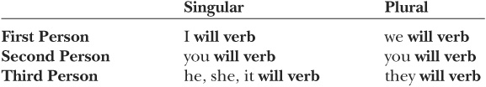

exercise 11-1

Complete each sentence with the simple future form of the verb in parentheses.
1. We ____________ (commute) to work with Megan next year.
2. The project patience. ____________ (require) a lot of hard work and
3. I ____________ (give) my report on Tuesday.
4. He ____________ (visit) his parents this weekend.
5. Dr. Kobashi ____________ (be) out of the office next week.
6. They ____________ (announce) the winners on the radio
7. Bob ____________ (leave) next month.
8. Lilik and Rebecca _____________ (complete) their training in February.
9. I ____________ (call) you tomorrow.
10. They ____________ (expand) the airport next year.

Forming Contractions: Pronouns with the Auxiliary Verb Will
In English, verbs are often combined with other words to form contractions. These shortened forms include an apostrophe (’) to indicate missing letters. It is important to learn contractions because you will often hear them in conversation or see them in informal writing. Formal writing, though, rarely contains contractions.
The modal auxiliary verb will is often combined with a pronoun to form a contraction. Notice that an apostrophe indicates that the letters w and i are omitted:
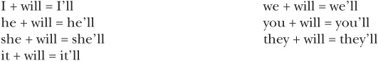

exercise 11-2

Complete each sentence with a contraction using the pronoun and the verb provided.
EXAMPLE: I, see
I’ll see you in the morning.
1. They, believe
your story.
2. I, deliver
the package myself.
3. You, like
their new apartment.
4. It, end
soon.
5. He, help
us.
6. She, introduce
you.
7. We, sit
together.

Forming Negatives
To form a negative, place not between the modal auxiliary verb will and the main verb,
will not go

exercise 11-3

Make each of the following sentences negative.
EXAMPLE: YOU WILL FIND YOUR BOOK OVER THERE.
You will not find your book over there.
1. He will finish by tomorrow.
2. You will have a lot of fun there.
3. She will know the answer.
4. We will ignore the problem.
5. They will keep your secret.
6. He will lie to you.
7. I will need help with my homework.
8. Marian will be alone.
9. I will mention your name.
10. They will be late.

Forming Contractions: Won’t
In conversation and informal writing, will and not are often contracted. The letter i in will changes to o in won’t. The apostrophe indicates that at least one letter is omitted:
will + not = won’t

exercise 11-4

Rewrite the sentences you wrote in exercise 11-3 using contractions.
1.
2.
3.
4.
5.
6.
7.
8.
9.
10.

Forming Yes/No Questions
To form questions that can be answered yes or no (yes/no questions), begin the question with the modal auxiliary verb will. After the modal verb, place the subject and the main verb.

Statement: You will be away a long time.
Yes/no question: Will you be away a long time?

exercise 11-5

Rewrite the following statements as yes/no questions.
EXAMPLE: YOU will know more tomorrow.
Will you know more tomorrow?
1. They will tell us on Friday.
2. She will report the incident.
3. You will laugh at my mistakes.
4. Mitch will need some help.
5. The noise will bother you.
6. He will lend us some money.
7. Dr. Silvis will be free at 4:00.
8. We will meet later.
9. They will use your plan.
10. Federal Express will deliver the package to our house.

Forming Wh-Questions
Wh-questions are used to elicit specific pieces of information. They usually begin with what, who, why, where, when, how, or combinations such as how much, how many, and how often. When the question word is the subject of the sentence, the form of the question is similar to the form of a statement.

Statement: McGraw-Hill will publish his new book.
Wh-question: Who will publish his new book?
When the question word is any other part of the sentence, the auxiliary modal verb will comes after the question word, followed by the subject and the main verb.

Statement: The play will begin at 8:00.
Wh-question: When will the play begin?

Statement: The package will contain two books and a CD.
Wh-question: What will the package contain?

exercise 11-6
Complete the following questions based on the statements provided.
EXAMPLE: My entire family will be there.
Who will be there?
1. His friends will repair his car.
Who
2. The class will meet on Tuesdays and Thursdays.
When
3. Rhonda will finish the report by Monday.
When
4. It will cost $30.00.
How much
5. They will blame me for the mistake.
Whom
(Who may be used instead of whom in conversation and informal writing.)
6. Professor Johnson and Professor Lee will choose the scholarship winners.
Who
7. The supervisor will be on vacation for two weeks.
How long
8. They will complain about the mess.
What
9. Two students from our class will lead the discussion.
Who
10. The dance group will perform on Thursday.
When
Unit 12 Be Going To
The phrasal modal auxiliary verb be going to is also used to indicate future time.
The verb be takes three different forms: am, is, and are.
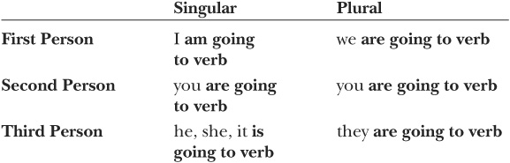
Be going to is less formal than will.
Friend to friend: I’m going to finish the project by Friday.
Employee to supervisor: I’ll finish the project by Friday.
Although sometimes be going to and will can be used interchangeably, there are two special uses. Be going to signals that something is imminent.
The alarm is going to sound in a second.
Will is used to make commitments.
I’ll meet you at 5:00.
You will learn more about modal auxiliary verbs in Part V.

exercise 12-1

Complete each sentence with a form of be going to and the main verb.
1. This job (be) difficult.
2. Our neighbors (build) a new garage.
3. My roommate (buy) a new printer.
4. I(cancel) my magazine subscription.
5. Members of the Outing Club (climb) Mt. Hood.
6. We (celebrate) tonight.
7. He (call) me today.
8. Matt (come) over this evening.
9. Someone from the firm (deliver) the letter tomorrow.
10. They (elect) a new prime minister this year.

exercise 12-2
Complete each sentence with either will or a form of be going to. Circle the reason that supports your answer.
1. Watch out. It _____________fall.
2. I _____________ work for you on Friday.
3. I _____________ sit down right now.
4. Sit down. The movie _____________ start.
5. Beth and I _____________ help you next week.

Forming Negatives
To make the phrasal modal verb be going to negative, just

exercise 12-3
Complete each of the following sentences using a negative form of be going to and the subject and verb provided.
EXAMPLE: He, accept
He is not going to accept the job offer.
1. Taxes, increase
this year.
2. It, snow
tonight.
3. We, go
to the party.
4. He, listen
to your advice.
5. She, travel
alone.
6. You, have
enough time.
7. I, forget
you.

Forming Contractions
Contractions are often formed by combining pronouns and the verb be or by combining the verb be and not. You will often hear these contractions in conversation or see them in informal writing, but you will rarely find them used in formal contexts.
Notice that an apostrophe indicates that a letter is omitted:
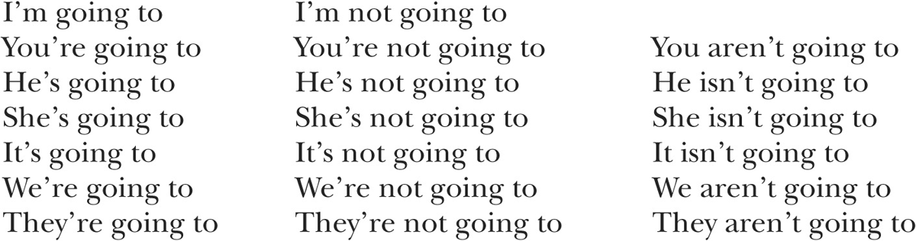

exercise 12-4
Complete the following sentences using contractions. For some sentences more than one form can be used.
EXAMPLE: He, appear
He’s going to appear on television this evening.
1. He, come, not
with us.
2. It, rain
soon.
3. I, clean
my room tonight.
4. They, believe, not
your story.
5. She, call, not
tonight.
6. You, do
well on the exam.
7. I, cook, not
anything special.

Forming Vos/No Questions
To form yes/no questions, begin the question with a form of the verb be and the subject.

Statement: They are going to win.
Yes/no question: Are they going to win?

exercise 12-5

Rewrite the following statements as questions.
EXAMPLE: He is going to design a new line of clothing?
Is he going to design a new line of clothing?
1. They are going to consider your proposal.
2. You are going to enter the park at the north gate.
3. The doctor is going to explain the procedure.
4. We are going to explore our new neighborhood today.
5. He’s going to fix it for free.
6. You are going to follow us.
7. She’s going to get into trouble.
8. It’s going to happen soon.
9. He’s going to like this idea.
10. We’re going to look for a new apartment today.

Forming Wh-Questions
In Wh-questions, when a question word is the subject of a sentence, the form of the question is similar to the form of a statement.

Statement: Judy is going to assist us.
Wh-question: Who is going to assist us?
When the question word is any other part of the sentence, place a form of the verb be and the subject after the question word.

Statement: They are going to leave next week.
Wh-question: When are they going to leave?

Statement: He is going to park the car in the corner lot.
Wh-question: Where is he going to park the car?

exercise 12-6
Complete the following questions based on the statements provided.
EXAMPLE: They are going to cut costs by closing some plants.
How are they going to cut costs?
1. My cousin is going to move to Chile.
Who
2. She is going to earn $10.00 an hour.
How much
3. We are going to eat late tonight.
When
4. They are going to improve the roads this year.
When
5. You are going to develop the film tomorrow.
When
6. They are going to invite everyone in the neighborhood.
Whom
(Who may be used instead of whom in conversation and informal writing.)
7. The legislators are going to discuss the bill on Friday.
When
8. He is going to live in Tokyo.
Where
9. My daughter is going to march in the parade.
Who
10. The eclipse is going to occur on Saturday.
When
Unit 13 Future Progressive (Will Merb + -ing)
Use the future progressive when you refer to an action or event that will be ongoing at some time or for some period of time in the future.
FUTURE ACTION OCCURRING FOR A PERIOD OF TIME: I will be studying all night.
FUTURE EVENT OCCURRING AT A POINT IN TIME: At approximately 7:30, the sun will be sinking behind the horizon.
The future progressive consists of the auxiliary verbs will and be and the -ing form of the main verb.
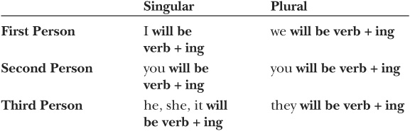
When a one-syllable word or a word with a stressed final syllable ends in a single consonant sound, double the last letter before adding -ing.
One-syllable word: plan → planning
Word ending in a stressed syllable: emit → emitting
BUT sew → sewing [This word ends in a vowel sound.]
When a word ends with a consonant and the letter e, drop the e before adding -ing: come → coming. The letter e is not dropped from words such as be, see, and free.

exercise 13-1
Complete each sentence with the future progressive form of the verb in parentheses.
1. Sean (represent) us at the meeting.
2. They (leave) at 6:00.
3. Their car (follow) ours.
4. We (wait) for you on the corner.
5. He (watch) the clock.
6. They (produce) more energy than they need.
7. The tour company (provide) lunch.
8. It (snow) in the mountains.
9. Look for me by the entry. I (wear) a red hat.
10. The Copy Shop (open) a new store downtown this year.

Forming Negatives
To make a future progressive verb negative, place not after will.
will not be flying

exercise 13-2

Complete each of the following sentences with a negative form of the future progressive. Use the subject and verb provided.
EXAMPLE: I, attend
I will not be attending the meeting.
1. They, appear
on television.
2. It, start
on time.
3. We, read
that novel this term.
4. He, arrive
in time for the party.
5. She, tay
in a hotel.
6. You, live
by yourself.
7. I, make
much money next year.

Forming Contractions
Contractions are often formed by combining pronouns and the auxiliary verb will or by combining the auxiliary verb will and not. You will often hear these contractions in conversation or see them in informal writing, but you will rarely find them used in formal contexts.
Remember that an apostrophe indicates that at least one letter is omitted and that the letter i in will changes to o in the negative contraction won’t:
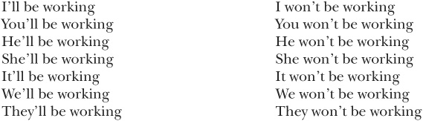

exercise 13-3

Use the pronoun and verb given to create a sentence that contains a contraction. If not is also given, use a negative contraction.
EXAMPLE: She, come, not
She won’t be coming to the party.
1. He, joining, not
us this evening.
2. It, affect
everyone.
3. I, treat
for dinner tonight.
4. They, need, not
any more help,
5. She, arrive, not
until midnight.
6. You, fly Tomorrow
to Honolulu.
7. I, think, not
of much besides the exam.

Forming Yes/No Questions
To form yes/no questions, begin the question with the auxiliary verb will. Follow will with the subject, be, and the -ing form of the main verb.

Statement: He will be coming along.
Yes/no question: Will he be coming along?

exercise 13-4

Rewrite the following statements as yes/no questions.
EXAMPLE: She will be playing for our team this year.
Will she be playing for our team this year?
1. I will be seeing you next week.
2. They will be traveling by bus.
3. Takamitsu will be assisting Heather.
4. They will be offering special packages at the end of the season.
5. You will be checking your e-mail daily.

Forming Wh- Questions
In wh-questions, when a question word is the subject of the sentence, the form of the question is similar to the form of a statement.

Statement: Debbie Little will be running for office next year.
Wh-question: Who will be running for office next year?
When the question word is any other part of the sentence, the auxiliary verb will comes after the question word and is followed by the subject, be, and the -ing form of the main verb.

Statement: They will be playing soccer on Sunday.
Wh-question: When will they be playing soccer?

exercise 13-5

Complete the questions below based on the statements provided.
EXAMPLE: Alison will be accompanying them.
Who will be accompanying them?
1. Kenji will be taking notes.
Who
2. The star of the show will be receiving an award.
Who
3. They will be sitting in the back row.
Where
4. You will be driving two hundred miles on your first day.
How far
5. She will be finishing her project in May.
When

Unit 14 Future Perfect
Use the future perfect when you want to refer to a future action, state, or event that will be completed by a specific time in the future.
FUTURE ACTION: By next week, she will have completed the course.
FUTURE STATE: In 2005, we will have known each other for twenty years.
FUTURE EVENT: The ship will have sunk by then.
The future perfect consists of the modal auxiliary verb will, the auxiliary verb have, and the perfect/passive form of the main verb. The perfect/passive verb form is used to indicate either the perfect aspect or the passive voice. (The passive voice will be discussed in Part IV.) The perfect/passive form for regular verbs consists of the base form of the verb and the ending -ed.
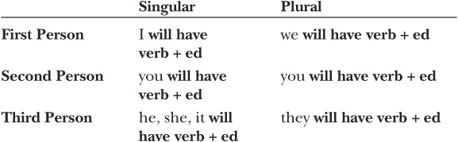
When a one-syllable word or a word with a stressed final syllable ends in a single consonant sound, double the last letter before adding -ed.
One-syllable word: flip → flipped
Word ending in a stressed syllable: refer → referred
BUT bow → bowed [This word ends in a vowel sound.]
The perfect/passive forms of irregular verbs can be found in the appendix.
If you would like to see the common patterns irregular verbs follow, see those listed for the present perfect on pages 29-30.

exercise 14-1

Complete each sentence with the future perfect form of the verb in parentheses. If you need help with irregular verb forms, check the appendix.
1. By the time you arrive, most guests (leave).
2. I (write) the report by the time you get here.
3. By 10:00 A.M., all the participants (introduce) themselves.
4. By the time they reach Sydney, they (fly) four thousand miles.
5. We (eat) dinner by the time they get here.

Forming Negatives
To make a future perfect verb negative, place not after will.
will not have gone

exercise 14-2

Make each sentence negative. Be sure to use the subject and the future perfect form of the verb provided.
EXAMPLE: admit
By the time he’s ninety years old, he still will not have admitted his mistake.
1. You, rest
before you meet the chair of the committee.
2. They, eat
By the end of the fast, they for twenty-four hours.
3. We, finish
our lunch by the time she arrives.
4. Mark, sleep
much before he makes his presentation.
5. She, save
enough money for college by the time classes begin.

Forming Contractions
Contractions are often formed by combining pronouns and the auxiliary verb will or by combining the auxiliary verb will and not. You will often hear these contractions in conversation or see them in informal writing, but you will rarely find them used in formal contexts.
Remember that an apostrophe indicates that at least one letter is omitted and that the letter i in will changes to o in the negative contraction won’t:
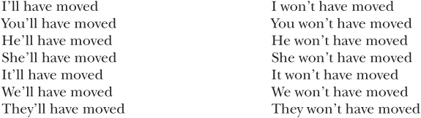

exercise 14-3

Use the pronoun and verb given to create a sentence that contains a contraction. If not is also given, use a negative contraction.
EXAMPLE: It, change
By next year, it’ll have changed.
1. They, complete
By the time the director arrives, the report.
2. He, finish, not
By the time I return,the work.
3. You, recover
By the end of May, completely.
4. They, make, not
much progress without our help.
5. She, give
the job to someone else by the time my application arrives.

Forming Vos/No Questions
To form yes/no questions, begin the question with the auxiliary verb will, following it with the subject, have, and the perfect/passive form of the main verb.

Statement: You will have completed your coursework by May.
Yes/no question: Will you have completed your coursework by May?

exercise 14-4
Rewrite the following statements as yes/no questions.
EXAMPLE: They will have discussed the issue by the time we arrive.
Will they have discussed the issue by the time we arrive?
1. The landscape will have changed by the time he’s an adult.
2. By July 11, we will have made our decision.
3. By the time you start your new job, you will have finished your degree.
4. By the time we get home, he will have called already.
5. When we get to the movie theater, the movie will have started already.

Forming Wh-Questions
In wh-questions, when the question word is the subject of the sentence, the form of the question is similar to the form of a statement.

Statement: Bruce will have resigned by the time the scandal appears in newspapers.
Wh-question: Who will have resigned by the time the scandal appears in newspapers?
When the question word is any other part of the sentence, the auxiliary verb will comes after the question word, followed by the auxiliary verb have, the subject, and the perfect/passive form of the main verb.

Statement: By the time you’re fifty years old, you will have worked at the firm for twenty-five years.
Wh-question: How long will you have worked for the firm by the time you’re fifty years old?

exercise 14-5

Complete the following questions based on the statements provided.
EXAMPLE: She will have received her results by the time she leaves our office.
When will she have received her results?
1. By the end of the season, Nat will have become the record holder.
By the end of the season, who
2. She will have lived in Moscow three months when her family arrives.
How long
3. By the time he’s thirty, Andy will have run sixteen marathons.
By the time he’s thirty, how many marathons
4. By the time it is built, they will have spent more than a million dollars.
By the time it is built, how much
5. When his new book comes out, he will have written ten novels.
When his new book comes out, how many novels _____________ _____

Unit 15 Future Perfect Progressive
When you want to refer to an ongoing action, state, or event or to a habitual action that will continue until or through a specific time, use the future perfect progressive.
HABITUAL ACTION: In October, we will have been commuting together for twenty years.
ONGOING EVENT: By that time, the temperature will have been increasing steadily for five years.
The future perfect progressive consists of three auxiliary verbs—will, have, and be—and the -ing form of the main verb. The auxiliary verbs will and have come first. Next is the perfect/passive form of the verb be—been. The final element of the future perfect progressive is the -ing form of the main verb.
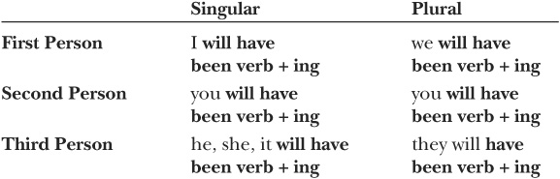

exercise 15.1
Complete each sentence with the future perfect progressive form of the verb in parentheses.
1. In December, we (live) in this house for ten years.
2. By the time of our next meeting, we (discuss) this plan for three years.
3. By the time of the recital, I (practice) four hours a day, seven days a week.
4. When the Mariners meet the Red Sox, they (play) on the road for six days already.
5. In June, they (work) together for thirty years.

Forming Negatives
To make a future perfect progressive verb negative, place not after the auxiliary verb will.
will not have been going

exercise 15-2

Complete each of the following sentences with a negative form of the future perfect progressive. Use the subject and verb provided.
EXAMPLE: He, answer, not
By the end of today, he will not have been answering his phone for a week.
1. They, talk, not
By Thursday, to each other for a week.
2. The subways, run, not By the end of the strike,
By the end of the strike, for six days.
3. They, produce, not
In January,that type of car for three years.
4. The dance troupe, perform, not
At the end of the December, for six days.
5. She, work, not
On Monday,for three months.

Forming Contractions
Contractions are often formed by combining pronouns and the auxiliary verb will or by combining the auxiliary verb will and not. You will often hear these contractions in conversation or see them in informal writing, but you will rarely find them used in formal contexts.
Remember that an apostrophe indicates that at least one letter is omitted and that the letter i in will changes to o in the negative contraction won’t:
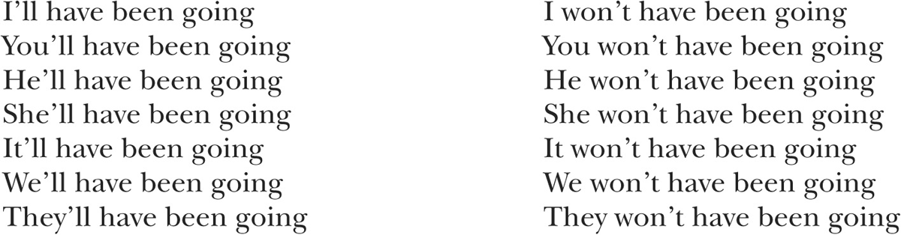

exercise 15-3
Use the pronoun and verb given to create a sentence that contains a contraction. If not is also given, use a negative contraction.
EXAMPLE: The foundation, donate
By next year, the foundation will have been donating money to that organization for five years.
1. They, work, not
By the end of February, the same shift for two months.
2. They, broadcast
By the end of this year, for fifty years.
3. We, rent
On Friday,this apartment for ten years.
4. They, return
In June,to the same place every summer for ten years.
5. He, assist, not
By the end of this month,us for a full year.

Forming Wh-Questions
In wh-questions, when the question word is the subject of the sentence, the form of the question is similar to the form of a statement.

Statement: When the project is finished, Cheryl will have been working more than anybody else.
Wh-question: When the project is finished, who will have been working more than anybody else?
When the question word is any other part of the sentence, the auxiliary verb will comes after the question word and is followed by the subject, the auxiliary verbs have been, and the -ing form of the main verb.

Statement: By the end of December, they will have been doing business together for twenty-five years.
Wh-question: By the end of the year, how long will they have been doing business together?

exercise 15.4
Complete the following questions based on the statements provided.
EXAMPLE: At the end of the summer, the band will have been playing together for five years.
At the end of the summer, how long will the band have been playing together?
1. By the end of June, Anne and Derrick will have been making the schedule for five years.
By the end of June, who
2. By Friday, the dance contestants will have been dancing for seventy-two hours.
By Friday, how long
3. By the end of July, we will have been using this computer for ten years.
By the end of July, how long
4. By Saturday, you will have been working on this paper for a whole month.
By Saturday, how long
5. By the end of the year, Ron will have been keeping a journal for five years.
By the end of the year, how long
Summary of Tense-Aspect Combinations

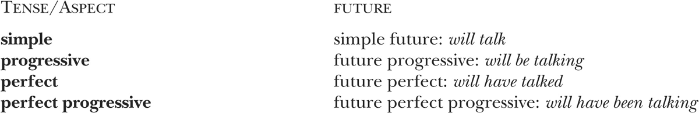

PART IV
IMPERATIVE, PASSIVE, AND HYPOTHETICAL CONDITIONAL
As you read the units that follow, you will learn to use verbs in three special constructions: the imperative, the passive, and the hypothetical conditional.
IMPERATIVE: Be careful!
PASSIVE: We were surprised by the news.
HYPOTHETICAL CONDITIONAL: If I were you, I would look for a new job.

Unit 16 Imperative
When you want to give instructions or directions, you can use the imperative:
INSTRUCTION: Mix the ingredients together.
DIRECTION: Turn right at the corner.
Imperatives are used for other purposes as well:
REQUEST: Close the window, please.
WARNING: Watch out!
INVITATION: Come over to our house tonight.
WISH: Have a nice time.
Using the verb in the imperative construction is easy because there are no endings. Just use the base form (the form found in the dictionary).
Because imperatives are directed toward another person or other persons, the subject you is understood; that is, it is not mentioned except for emphasis.

exercise 16-1

Choose a verb from the list to complete the imperative sentences.
1. Please _____________ the telephone.
2. _____________ a nice weekend.
3. _____________ the door, please.
4. Please _____________ quiet.
5. _____________ your work by Friday.
6. _____________ an ambulance!
7. _____________ the cookies for fifteen minutes.
8. _____________ me in the hotel lobby.
9. _____________ left at the corner.
10. _____________ safely.

Forming Negatives
To form a negative imperative, place the auxiliary verb do and the word not before the base form of the verb.
do not go

Forming Contractions: Don’t
In informal or conversational situations, use a contraction.
don’t go

exercise 16-2

Complete the following sentences using the negative form of the verb provided. Then rewrite the sentence using a contraction.
EXAMPLE: walk
Do not walk on the grass.
Don’t walk on the grass.
1. Be
late!
2. Run
on the deck of the pool.
3. Forget
your homework.
4. Lie
to me.
5. Shout
at us.
6. Drink
the water.
7. Start
the car yet.
8. Blame
me.
9. Boil
the water too long.
10. Break
anything.

Forming Contractions: Let’s
The contraction let’s (for let us) is often used to make suggestions.

Let’s go to the movies.
Let’s not wait any longer.
The uncontracted form is used only in very formal situations—religious ceremonies, for example.

Let us join together in prayer.

exercise 16-3
Use let’s or let’s not to complete the following sentences. Use the verb provided.
1. make
something easy for dinner.
2. forget, not
the tickets.
3. stay, not
at the party very late.
4. call
Anna and Charlie.
5. celebrate
tonight.
Unit 17 Passive
The sentences that you studied in Parts I through III were in the active voice. Most of them had subjects that performed actions. In contrast, sentences in the passive voice have subjects that receive some action.
ACTIVE: George Lucas produced the film.
PASSIVE: The film was produced by George Lucas.
In passive sentences, the doer of the action is sometimes in a prepositional phrase starting with the preposition by, as in “by George Lucas.” In other instances, there is no by phrase because the doer of the action is not important or is not known.
Microcomputers were used in the study.
In passive sentences, the main verb is in the perfect/passive form. You have already studied this form in Parts I, II, and III. To refresh your memory, see pages 29–30, 69, and 101. The auxiliary be precedes the perfect/passive form of the main verb.
Oranges are grown in Florida.
In the present tense, regular verbs follow this pattern:
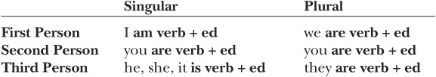
Contracted forms: I’m, you’re, he’s, she’s, it’s, we’re, they’re
The pattern for regular verbs in the past tense is as follows:
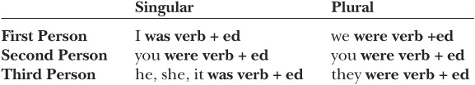
No contracted forms
Both the modal verb will and the auxiliary verb be are used to signal the future:
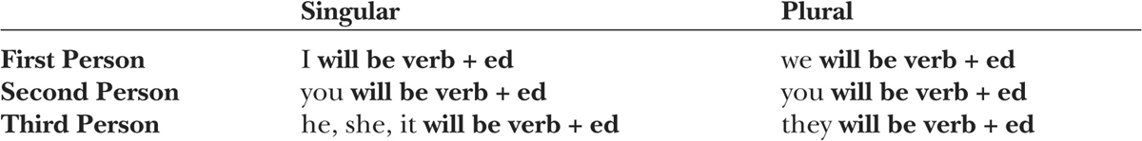
Contracted forms: I’ll, you’ll, he’ll, she’ll, it’ll, we’ll, you’ll, they’ll
For the perfect/passive forms of irregular verbs, consult the appendix.

exercise 17-1

Complete each passive sentence with the form of the verb indicated in parentheses. Then rewrite the sentence using a pronoun and, if possible, a contraction.
EXAMPLE: The experiment will be performed (perform, future) tomorrow.
It’ll be performed tomorrow.
1. James (reward, future) for his work.
2. The students (affect, past) by the changes in the tax law.
3. Newspapers (deliver, present) daily.
4. Potatoes (grow, present) in Idaho.
5. The winners (announce, past) yesterday.
6. Your schedules (change, future) next week.
7. The soccer match (reschedule, future).
8. All the students in class (invite, present) to the party.
9. Carmen (blame, past) for the error.
10. The house (destroy, past).

Progressive Verbs in the Passive Voice
Progressive verbs in the passive voice have an additional auxiliary verb be, which has the progressive -ing ending: being.
Present progressive verbs in the passive voice follow this pattern:
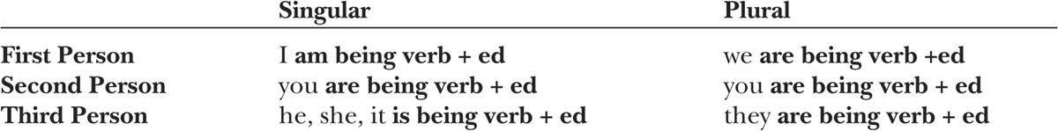
Contracted forms: I’m, you’re, he’s, she’s, it’s, we’re, they’re
Past progressive verbs are similar, but the tense of the first auxiliary be changes:
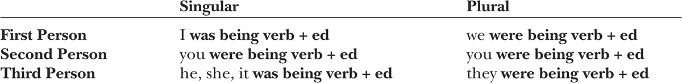
No contracted forms
The future progressive is rarely used, so it will not be presented here.

exercise 17-2

Complete each passive sentence with the form of the verb indicated in parentheses. Then rewrite the sentence using a pronoun and, if possible, a contraction.
EXAMPLE: A new rocket is being designed (design, present progressive).
It’s being designed.
1. This event (broadcast, present progressive) around the world.
2. New uses for recycled materials (develop, present progressive).
3. The luggage (carry, past progressive) to the plane when one of the suitcases popped open.
4. The issues (discuss, past progressive) when we arrived.
5. Your job application (consider, present progressive).
6. Our passports (check, past progressive) when the alarm rang.
7. New council members (elect, present progressive) this year.
8. That store (close, present progressive) because of safety problems.
9. The protestors (ignore, past progressive) by the politicians.
10. Donations (collect, present progressive) for the poor.

Perfect Verbs in the Passive Voice
Perfect verbs in the passive voice have two auxiliary verbs—have, which carries tense, and be, which is in the perfect/passive form been.
Present perfect verbs in the passive voice follow this pattern:
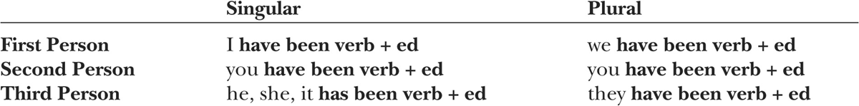
Contracted forms: I’ve, you’ve, he’s, she’s, it’s, we’ve, they’ve
Past perfect verbs are similar, but the form of the first auxiliary changes to had to indicate the past tense:
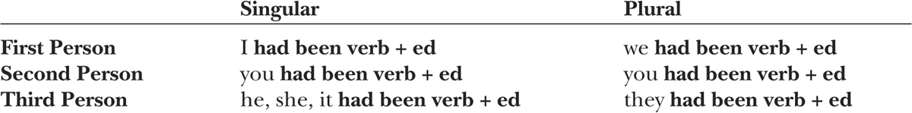
Contracted forms: I’d, you’d, he’d, she’d, it’d, we’d, they’d
Future perfect verbs include the modal verb will, as well as the auxiliaries have and be:
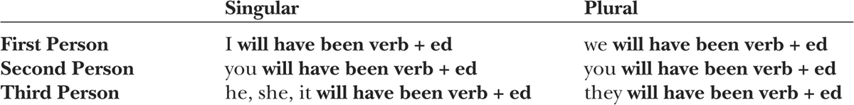
Perfect progressive verbs in the passive voice are extremely rare; they will not be presented here.

exercise 17-3
Complete each passive sentence with the form of the verb indicated in parentheses. Then rewrite the sentence using a pronoun and, if possible, a contraction.
EXAMPLE: The lost information has been retrieved. (retrieve, present perfect).
It’s been retrieved.
1. My brother (promote, present perfect).
2. The jobs (assign, future perfect) by the time we arrive.
3. My parents (delay, past perfect) at the airport, so they were late.
4. The work (finish, future perfect) when the director meets with us.
5. Her first book (praised, past perfect) highly.
6. Amy and I (notify, future perfect) of any problems before we leave.
7. The arrangements (make, present perfect).
8. The job (offer, present perfect) to Laila.
9. The report (revise, present perfect).
10. The roads (improve, past perfect) since my previous visit.

Forming Negatives
To form a negative sentence, place the word not after the first auxiliary verb.
Examples: is not spoken, is not being written, has not been read, will not have been noticed

exercise 17-4
Make each of the following sentences negative.
EXAMPLE: The cause of the fire was discovered.
The cause of the fire was not discovered.
1. The game was canceled.
2. Rita has been fired.
3. By this time next year, the project will have been completed.
4. Some of the important issues are being discussed.
5. Our bags are being searched.
6. Your x-rays will be returned to you.
7. The recent findings are being presented to the public.
8. The cell phone had been taken from the car.
9. This computer has been used before.
10. The document is being prepared by the secretary.

Forming Questions
Passive questions are formed in two ways. For yes/no questions and for wh-questions in which the question word is not the subject, the first (or only) auxiliary verb begins the question and is followed by the subject.

Has the letter been sent?
When will the letter be sent?
When the question word is the subject, it begins the question and is followed by the auxiliary and main verbs.
What was sent?

exercise 17-5

Rewrite the following statements as yes/no questions.
EXAMPLE: The report was revised.
Was the report revised?
1. All questions were answered.
2. Everyone has been notified of the cancellation.
3. The basketball game will be broadcast.
4. The road is being repaired.
5. Enough evidence had been collected.
6. He was impressed by the report.
7. The costs for the project have been calculated.
8. Jobs are being cut.
9. Solutions to the problem are being explored.
10. The clock will be fixed tomorrow.

exercise 17-6
Complete the following questions based on the statements provided.
EXAMPLE: His car was stolen.
What was stolen?
1. Catherine Haley has been elected.
Who
2. The cave was explored.
What
3. Shoshona was given a scholarship.
Who
4. Pineapple is grown in Hawaii.
What
5. My old teacher is being honored at the special dinner tonight.
Who
6. The invitations are being sent on Friday.
When
7. The books were moved to the new library last year.
When
8. The new lights are being installed in all the classrooms.
Where
9. Thirty-two credits are required for graduation.
How many credits
10. The furniture was damaged in the fire.
What
Unit 18 Hypothetical Conditional
The sentences you will study in this unit have two parts: an if clause and a main clause. The if clause consists of a condition that is either slightly possible or impossible; the main clause states the consequences of the condition mentioned in the if clause.
SLIGHTLY POSSIBLE: If he felt better, he would come with us.
IMPOSSIBLE: If my aunt were still alive, she would be a hundred years old today.
To form a hypothetical conditional that refers to present or future time, use the simple past tense in the if clause; use a modal verb (either would, might, or could) and the base form of the main verb in the main clause.
If he studied more, he would earn better grades.
In formal English, were is used in the if clause, even following the first- and third-person singular pronouns.
If I were you, I would look for a job.
If she were here, we could leave.
To form a hypothetical conditional that refers to past time, use the past perfect in the if clause; use would have, might have, or could have and the perfect/passive form of the main verb in the main clause.
If they had asked earlier, I could have helped them.

exercise 18-1

Complete each conditional sentence with the correct form of the verb in parentheses. Each sentence refers to either present or future time. In the main clause, use would before the base form of the verb.
1. If I _______________ (be) the director, I _______________ (change) the policy.
2. If you _______________ (check) your e-mail more often, you _______________ (know) about the assignments.
3. If we _______________ (commute) together, the drive _______________ (cost) less.
4. If he _______________ (have) more time, he _______________ (go) to the game with us.
5. If Emma _______________ (visit) us on Thursday, she _______________ (meet) my sisters.
6. If you _______________ (mail) the package today, they _______________ (receive) it by Friday.
7. If they _______________ (lower) their prices, more people _______________ (shop) there.
8. If we _______________ (earn) more money, we _______________ (buy) a new car.
9. If he _______________ (exercise) more frequently, he _______________ (be) healthier.
10. If my grandfather _______________ (be) here, he _______________ (tell) a joke.

exercise 18-2

Complete each conditional sentence with the correct form of the verb in parentheses. Each sentence refers to past time. In the main clause, use would have before the perfect/passive form of the verb.
1. If it _______________ (rain), they _______________ (cancel) the game.
2. If you _______________ (be) on the roller coaster, you _______________ (be) sick.
3. If I _______________ (know) about the detour, I _______________ (take) another route.
4. If she (follow) the directions, she _________(be) on time.
5. If I (study) harder, I __________ (pass) the exam.
6. If he _______________ (be) more productive, he _______________ (receive) a promotion.
7. If they _______________ (raise) tuition, the students _______________ (protest).
8. If they _______________ (repair) the car yesterday, we _______________ (leave) today.
9. If you _______________ (revise) your paper, your main points _______________ (be) clearer.
10. If I _______________ (be) the manager, I _______________ (hire) Yoshi.

PART V
PHRASAL VERBS AND MODAL AUXILIARY VERBS
As you study the units that follow, you will learn about two special types of verbs: phrasal verbs and modal auxiliary verbs. Phrasal verbs are verb-particle combinations, such as look up in I’ll look up his phone number. Modal auxiliary verbs are auxiliaries that signal such meanings as obligation and possibility. Although you have been introduced to modal auxiliary verbs in previous units (will and would, for example), in Part V you will learn more about the subtle shades of meaning that tense and aspect add to these verbs.

Unit 19 Phrasal Verbs
Phrasal verbs are combinations of verbs and particles. Common particles include in, on, off, up, down, and out. Verb + particle combinations carry their own meanings. In other words, the verb and the particle work together to create meaning.
The plane took off ten minutes ago. [“left the ground”]
We turned in our papers. [“submitted”]
You can find the definitions of phrasal verbs in most dictionaries made for learners of English.
Phrasal verbs can appear in all the tense-aspect combinations you have studied so far. The following chart includes the tense-aspect combinations for turn up:
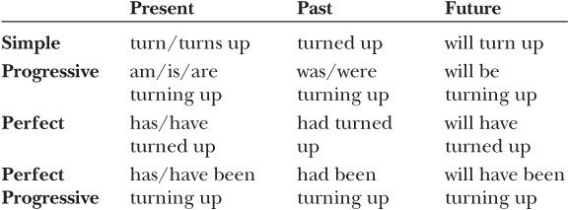

exercise 19-1
Complete the following chart using the correct forms of the phrasal verb go out. Remember that go is an irregular verb.
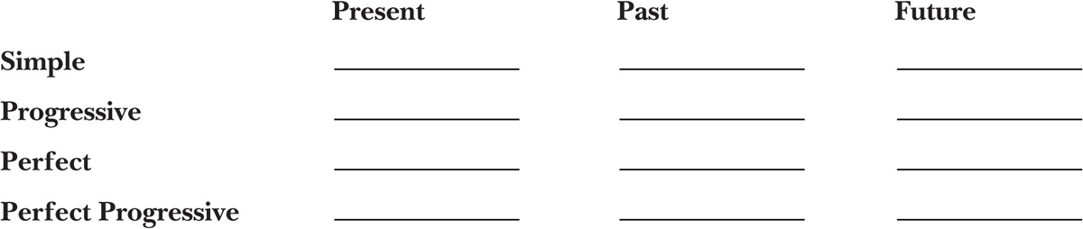

exercise 19-2

Complete each sentence with the form of the phrasal verb indicated in parentheses.
EXAMPLE: They took apart (take apart, simple past) the engine.
1. The towing company (take away, present perfect) the old car.
2. He (put on, past progressive) his hat when the doorbell rang.
3. We (find out, simple future) the results today.
4. I (look up, present progressive) their phone number.
5. I (sign up, future progressive) for four courses this term.
6. The planning committee (put off, past perfect) the event once again.
7. Ray (read through, future perfect) the report by Friday.
8. The publishing company (put out, present perfect progressive) a new book every month.
9. By the end of the day, the actors (go over, future perfect progressive) their lines for ten hours.
10. We (take out, simple present) the trash every Thursday night.
11. The tour guide (point out, simple past) some important sites.
12. For years, Lixing (pay back, past perfect progressive) his loan month by month.

Phrasal Verbs in the Passive Voice
Phrasal verbs may also be used in the passive voice:
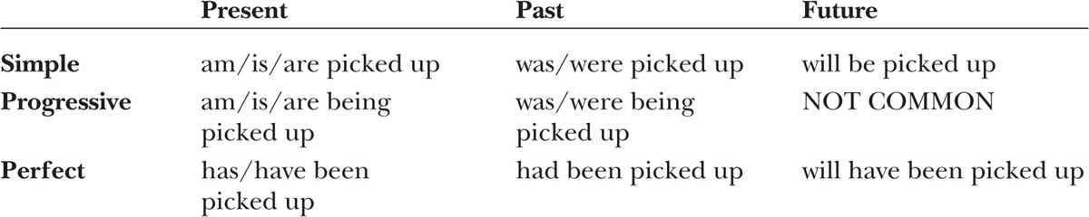

exercise 19-3
Complete the following chart using the correct passive forms of the phrasal verb set up. Remember that set is an irregular verb.
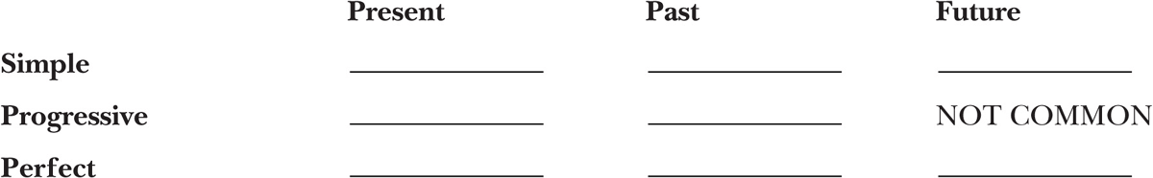

exercise 19-4

Complete each sentence with the passive form of the phrasal verb indicated in parentheses.
EXAMPLE: The interviews were written up (write up, simple past) in time for the conference.
1. All the food at the party (eat up, past perfect).
2. Our car (block in, simple past) by another car.
3. The fire (put out, present perfect).
4. His photograph (blow up, simple future) and published in the local newspaper.
5. The project (slow down, present progressive) by endless regulations.
6. Change______________ (bring about, simple present) only through much effort.
7. Their house (break into, past progressive), so we called the police.
8. By next year, three new products _____________ (bring out, future perfect).

Separable Phrasal Verbs
Phrasal verbs that take direct objects are often separable: the direct objects can be placed between the verb and the particle.

Angela threw away the letter.
Angela threw the letter away.
When the direct object is a pronoun, it must be placed between the verb and the particle.

Angela threw it away.

exercise 19-5

Rewrite the following sentences so that the direct object is between the verb and the particle. Then rewrite the sentence replacing the direct object with a pronoun.
EXAMPLE: The instructor quickly passed out the exams.
The instructor quickly passed the exams out.
The instructor quickly passed them out.
1. She brought back the books yesterday.
2. They called off the game.
3. I checked out the book on Monday.
4. I crossed out some names.
5. Someone turned off the washing machine.
6. I called up my parents last night.
7. She closed up her suitcase and put it on the scale.
8. I cleaned out my desk this morning.
9. She wrote down the number.
10. They gave away their old furniture.
11. Victor helped out his sister.
12. She took down a map and gave it to us.

Forming Negatives
You studied the ways to make verbs negative in Parts I, II, and III. Phrasal verbs follow these same patterns.
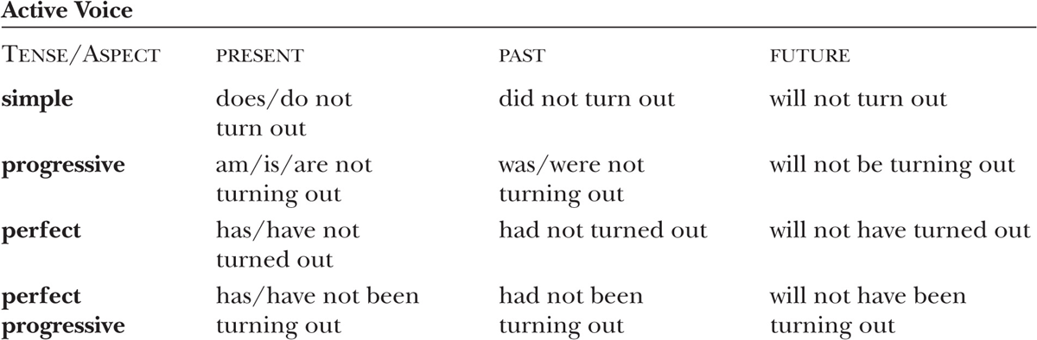
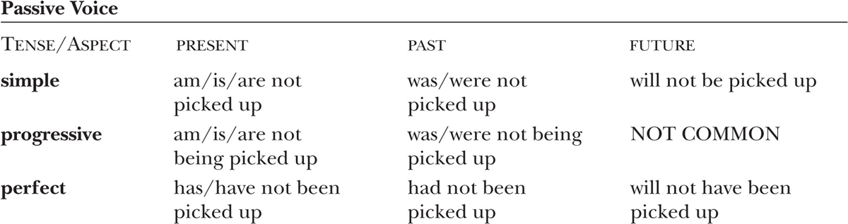

exercise 19-6

Make each of the following sentences negative.
EXAMPLE: The wind blew it down.
The wind did not blow it down.
1. Jacob is writing down the address.
2. She has booted up the computer.
3. The hot weather was wearing us down.
4. The books were brought back yesterday.
5. The painting on the sidewalk has been washed off.
6. I am bringing my friend over tonight.
7. They vote down most proposals.
8. He made up the story.
9. I will print out my paper on that printer.
10. The report was turned in on time.
11. She set it down carefully.
12. They had been locked out of their car before.

Unit 20 Modal Auxiliary Verbs
Modal auxiliary verbs appear before main verbs. They are used for a number of purposes. Here are some of the most common:
INDICATE ABILITY: She can speak English.
GIVE ADVICE: YOU should see a doctor.
EXPRESS CERTAINTY: We will finish by 8:00.
INDICATE POSSIBILITY: It may rain tonight.
INDICATE OBLIGATION: You must attend the last class.
GIVE PERMISSION: You may use your dictionaries during the exam.
INDICATE PAST HABIT: When I was little, we would go swimming every day.
Unlike other verbs, modal verbs have only one form. In other words, no -s is added to modal verbs to indicate third-person singular.
He/she/it can/should/will/may/must move.

exercise 20-1

Complete each sentence with the modal auxiliary verb that provides the meaning indicated in parentheses.
1. You _____________ (certainty) receive a flight confirmation in the mail.
2. We _____________(advice) leave in ten minutes.
3. There _____________ (possibility) be a storm tonight.
4. A notary public _____________ (obligation) sign the form.
5. Alicia _____________(ability) draw well.
6. As a child, he _____________ (past habit) play soccer every day.
7. _____________ (permission) I borrow your pencil?
8. Pets _____________ (obligation) be on leashes.
9. I _____________ (possibility) leave work early tonight.
10. The package _____________ (certainty) be delivered by noon.
11. They _____________ (advice) be more careful.
12. _____________ (ability) you come with us on Saturday?
13. You _____________ (permission) enter the restricted area.
14. When we lived in San Diego, we _____________ (past habit) often go to the beach.

Semi-Modal Auxiliary Verbs
English also has semi-modal auxiliary verbs. They are used for many of the same purposes as modal auxiliary verbs.

INDICATE ABILITY: He is able to speak three different languages.

GIVE ADVICE: you ought to finish the report.

EXPRESS CERTAINTY: We are going to complete the project tonight.

INDICATE OBLIGATION: You have to attend the meeting.

INDICATE PAST HABIT: We used to play basketball together.
Unlike one-word modal verbs, most semi-modals are marked for number and tense.
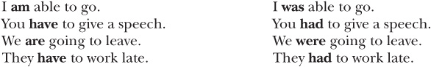
Used to is an exception. It has only one form and always refers to the past. Ought to is another exception. It does not change form; however, the main verb that follows it can.

exercise 20-2

Complete each sentence with the semi-modal verb that provides the meaning indicated in parentheses. Use present tense forms.
1. You _____________ (certainty) receive an award at the ceremony.
2. We _____________ (advice) exercise daily.
3. Jorge and I _____________ (past habit) play in a band.
4. We _____________ (obligation) pay our tuition by Friday.
5. Devin _____________ (ability) run the mile in five minutes.
6. I _____________ (past habit) live in New York City.
7. He _____________ (advice) take a multivitamin every morning.
8. You _____________ (obligation) have a password.
9. They _____________ (ability) help us move into our new apartment.
10. The concert _____________ (certainty) start at 8:00.

exercise 20-3

Complete each sentence with the semi-modal verb that provides the meaning indicated in parentheses. Use the past tense if possible.
1. It _____________ (certainty) rain, so we left early.
2. She _____________ (advice) have rested.
3. We _____________ (obligation) pay a service charge.
4. The teacher _____________ (ability) remember everyone’s name.
5. I _____________ (certainty) go with them, but then I got sick.
6. My father _____________ (advice) have had a checkup yesterday.
7. Amber _____________ (obligation) retype her paper, because she lost her disk.
8. They _____________ (ability) hike long distances when they were young.

Combining Semi-Modals
Sometimes semi-modals can be used with other semi-modals or after some regular modals.

They are going to have to finish their papers by Friday. [semi-modal + semi-modal]
I will have to call you back later. [modal + semi-modal]

exercise 20-4

Underline the modals and circle the semi-modals in the following sentences.
1. I might be able to help you on Thursday.
2. They are going to be able to take a vacation next month.
3. She might have to quit her job.
4. You are going to have to work hard.
5. We will have to take notes at the lecture.

Forming Negatives
To make a modal negative, place not after it.

I should not eat so much at lunch.
Write the combination of can and not as one word: cannot. Write the other combinations as two words.
To make a semi-modal containing the verb be negative, place not directly after the be verb.

Our teacher is not going to cancel the exam.
To make a semi-modal containing the verb have negative, place the auxiliary verb do and not before it.

Jay does not have to go to class today.

exercise 20-5

Complete each of the following sentences using a negative form of the modal or semi-modal provided.
EXAMPLE: We, be going to
We are not going to go to the movies tonight.
1. You, should
smoke in this restaurant.
2. We, can
escape the heat today.
3. Martin, be able to
find his books.
4. The supervisor, be going to
be happy.
5. They, may
stay very long.
6. You, must
tell anyone.
7. We, would
When we were little, go inside until 10:00.
8. They, will
For some reason, answer their phone.
9. I, have to
Tomorrow, get up early.
10. You, should
worry so much.

Forming Contractions
Contractions are commonly used in conversation and informal writing.
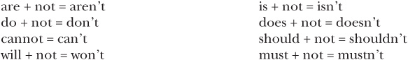
May not is never contracted.

exercise 20-6
Rewrite the sentences in exercise 20-5 using contractions. If may not appears, leave the line blank.
1.
2.
3.
4.
5.
6.
7.
8.
9.
10.

Modal Perfect Verbs
Modal perfect verbs follow these patterns:

ACTIVE VOICE: modal + have + perfect/passive form of the verb

PASSIVE VOICE: modal + have been + perfect/passive form of the verb
These are some of the common uses:

EXPRESSION OF REGRET: I should have tried harder.

CRITICISM OF A PAST ACTION OR LACK OF ACTION: He should have told me. She could have at least called. They ought to have told me.

EXPRESSION OF AN EXPECTATION ABOUT AN EVENT THAT MAY NOT HAVE HAPPENED: They should have arrived by now.

GUESS ABOUT A PAST EVENT: The window may have been shattered by the wind. I might have met him before.

STRONG CONJECTURE ABOUT A PAST EVENT: Someone must have stolen my purse.

exercise 20-7
Complete each sentence with the modal perfect verb that provides the meaning indicated in parentheses.
1. I _____________ (regret, active voice) sent her a birthday card.
2. We _____________ (expectation, active voice) heard from them by now.
3. They _____________ (criticism, active voice) invited everyone in class, not just a few people.
4. The store _____________ (guess, passive voice) closed early because of an emergency.
5. The Angels _____________ (strong conjecture, active voice) won.
6. By this time, everyone _____________ (expectation, active voice) been ready.
7. You _____________ (guess, active voice) lost your wallet in the café.
8. I _____________ (regret, active voice) brought an umbrella.
9. There _____________ (strong conjecture, active voice) been an accident in this intersection.
10. The package _____________ (criticism, passive voice) delivered earlier.

PART VI
GERUND AND INFINITIVE COMPLEMENTS
Gerunds and infinitives are verb forms, but they are not used as the main verbs in sentences. Gerunds are formed by adding -ing to the base form of a verb: running, talking, doing. (The -ing form is often called the present participle.) Infinitives consist of two parts: the infinitive marker to and the base form of a verb: to run, to talk, to do. Gerunds and infinitives can follow main verbs.
She enjoys playing the guitar.
He promised to sing for us.
Some verbs, such as enjoy, are followed by gerunds. Others, such as promise, are followed by infinitives. But some verbs can be followed by either gerunds or infinitives.
I like reading mysteries.
I like to read mysteries.
Generally, gerunds signal that an action has happened or is especially vivid. Infinitives indicate future or hypothetical events.

Unit 21 Gerunds
Gerunds have four forms:
SIMPLE: She avoids driving during rush hour.
PERFECT: He admits having taken the documents.
PASSIVE: They dislike always being put in the last row.
PASSIVE PERFECT: I appreciate having been given this opportunity.
The following verbs can be followed by gerunds but cannot be followed by infinitives:
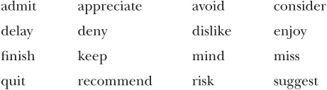

exercise 21-1

Complete each sentence with the form of the gerund indicated in parentheses.
EXAMPLE: Albert considered living (live, simple) abroad for a year.
1.My brother and his wife delayed _____________ (have, simple) children until they were settled.
2.I miss _____________ (surprise, passive) on my birthday by my grandfather.
3.The politician denied _____________ (mention, perfect) a possible tax increase.
4. I keep _____________ (try, simple) his number, but he doesn’t answer.
5.They didn’t mind _____________ (invite, passive perfect) at the last minute.
6.The doctor recommended _____________ (eat, simple) more fruits and vegetables.
7.I appreciate _____________ (choose, passive perfect) as your representative.
8.The committee finished _____________ (review, simple) the applications yesterday.
9.We admitted _____________ (be, perfect) the source of the trouble.
10.He dislikes _____________ (treat, passive) as a child.
11.The tour guide suggested _____________ (stop, simple) for lunch at this restaurant.
12.Fortunately, we avoided _____________ (give, passive) a ticket.
13.For some reason, she quit _____________ (play, simple) the piano a year ago.
14.When he made the repair, he risked _____________ (damage, simple) the whole system.
15.We enjoyed _____________ (introduce, passive) to your family.

exercise 21-2

Use gerunds to answer the following questions.
EXAMPLE: What sport do you like playing?
I like playing soccer.
1.What do you enjoying doing on holidays?
2.What have you avoided doing in the past year?
3.What do you dislike doing on the weekend?
4.What story did you like being told when you were a child?
5.Whom do you miss seeing whom you cannot see now?
Unit 22 Infinitives
Infinitives have a number of forms. These are the most common:
SIMPLE: Eva wants to become a lawyer.
PROGRESSIVE: They seem to be telling the truth.
PERFECT: He hopes to have finished his work by next Friday.
PASSIVE: Anna deserves to be promoted.
PASSIVE PERFECT: We pretended to have been surprised.
The following verbs can be followed by infinitives but cannot be followed by gerunds:
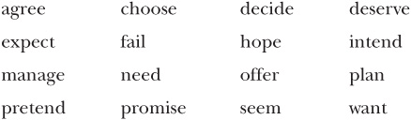

exercise 22-1

Complete each sentence with the form of the infinitive indicated in parentheses.
EXAMPLE: Janine managed to find (find, simple) an apartment on the first day of her search.
1. I plan _____________ (work, progressive) full-time next year.
2. He agreed _____________ (pay, simple) me for the photographs.
3. She hopes _____________ (earn, perfect) a raise by the end of this year.
4. The child pretended _____________ (faint, perfect).
5. Shoba deserves _____________ (hire, passive) for the new position.
6. Everyone offered _____________ (help, simple) us.
7. The announcement seems _____________ (leak, passive perfect) to the press.
8. In order to get that job, he needs _____________ (network, progressive).
9. The director expected _____________ (receive, perfect) the report by now.
10. The reporter had wanted _____________ (give, passive) a different assignment.
11. I promise _____________ (meet, simple) you there at 5:00.
12. My parents decided _____________ (stay, simple) an extra week.
13. He failed _____________ (turn in, simple) the work on time.
14. Our neighbors intend _____________ (move, simple) next year.
15. The company chose _____________ (close, simple) one of the plants.

exercise 22-2

Use infinitives to answer the following questions.
EXAMPLE: What did you expect to learn in this book?
I expected to learn about English verbs.
1. Where do you plan to go this weekend?
2. Where do you intend to be next year at this time?
3. What do you need to buy this week?
4. What do you want to have for dinner?
5. What do you expect to study next term?

Verbs Followed by a Noun Phrase and an Infinitive
Some verbs are followed by both a noun phrase (a pronoun or a noun and any of its modifiers) and an infinitive:
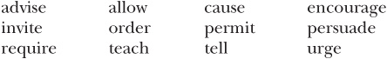

exercise 22-3

Complete each of the following sentences using the noun phrase provided and the simple form of the infinitive.
EXAMPLE: us, go
The teacher encouraged us to go to the lecture.
1. him, exercise
Dr. Olson advised more frequently.
2. us, attend
Carl invited his piano recital.
3. my sister, ride
My brother taught a bike.
4. me, turn
He told left at the corner.
5. people, touch
The museum guide permitted some of the exhibits.
6. Brent and me, be
The accident caused more careful the next time.
7. local artists, hang
Laura Adams allowed their paintings in her restaurant.
8. the protesters, leave
The police ordered
9. me, rethink
My parents persuaded my plan.
10. employers, provide
The new law required .safety training
11. Robyn, major
Mr. Pruett encouraged in biology.
12. everyone, conserve
The president urged energy.
Unit 23 Gerunds or Infinitives
Some verbs can be followed by either gerunds or infinitives. Sometimes there is no significant difference in meaning between a sentence with a gerund and a sentence with an infinitive.
He began humming.
He began to hum.
The most common verbs falling into this category are the following three verbs dealing with time:
The verb stop, however, is used to express two different meanings.
We stopped singing. [The singing has ended.]
We stopped to sing. [The singing has not started yet.]
After verbs dealing with emotion, the gerund is generally used to express the vividness of an action, an event, or a state or to indicate its actual occurrence. The infinitive usually indicates a future, potential, or hypothetical action, event, or state.
I usually prefer cooking my own food, but tonight I would prefer to go out.
The following verbs fall into this category:
Some verbs dealing with memory signal different time sequences, depending on whether a gerund or an infinitive is used.

I remember locking the door. [The door was locked; then the action of locking was remembered.]

I remembered to lock the door. [The remembering of a responsibility took place before the action of locking was performed.]
The following verbs fall into this category:

exercise 23-1
Underline the gerund or infinitive. Circle the reason that the gerund or the infinitive is used. If either a gerund or infinitive could be used, circle “No significant change in meaning.”
1. It started to rain.
2. I remembered to bring a lunch.
3. He regretted quitting that job.
4. They continued to talk during the entire movie.
5. My friends and I love going to the beach.
6. I would hate to clean up that mess.
7. Laxmi remembers returning the books to the library.
8. My neighbors like throwing huge parties.
9. The car began to make strange noises.
10. I prefer to take classes at night.
APPENDIX
Chart of Irregular Verbs
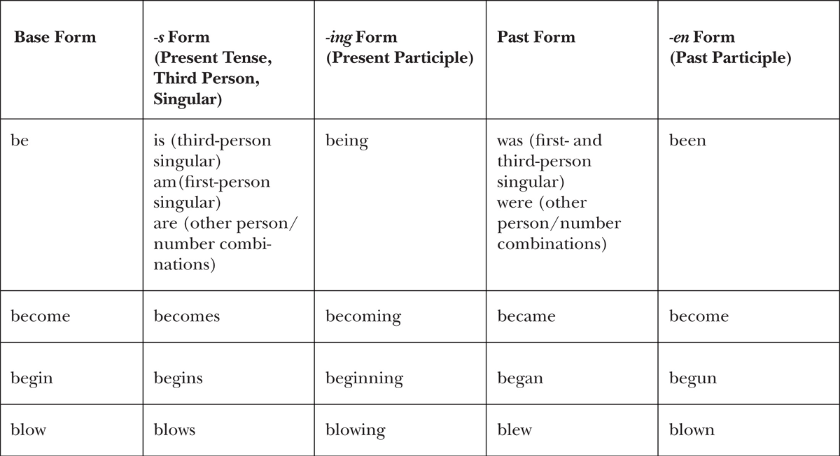
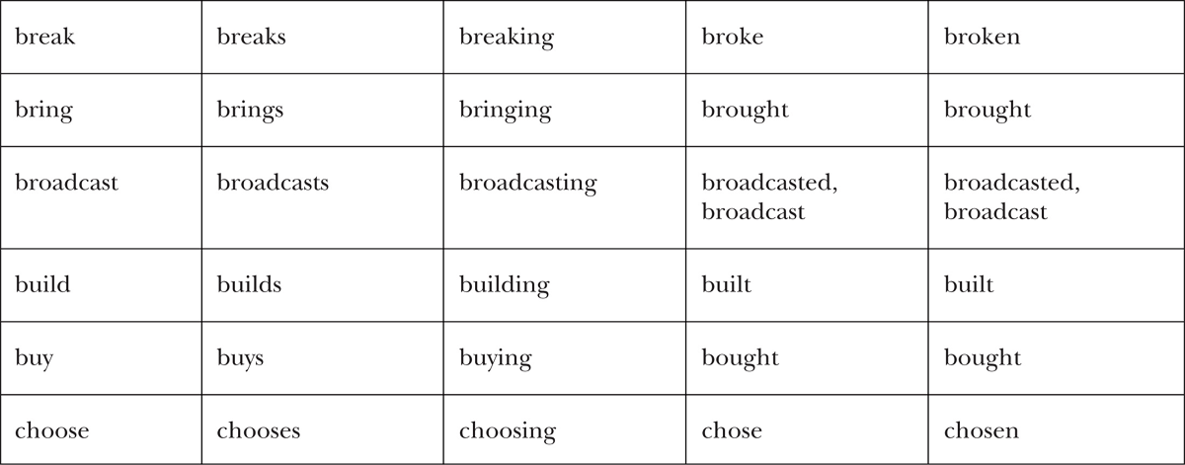
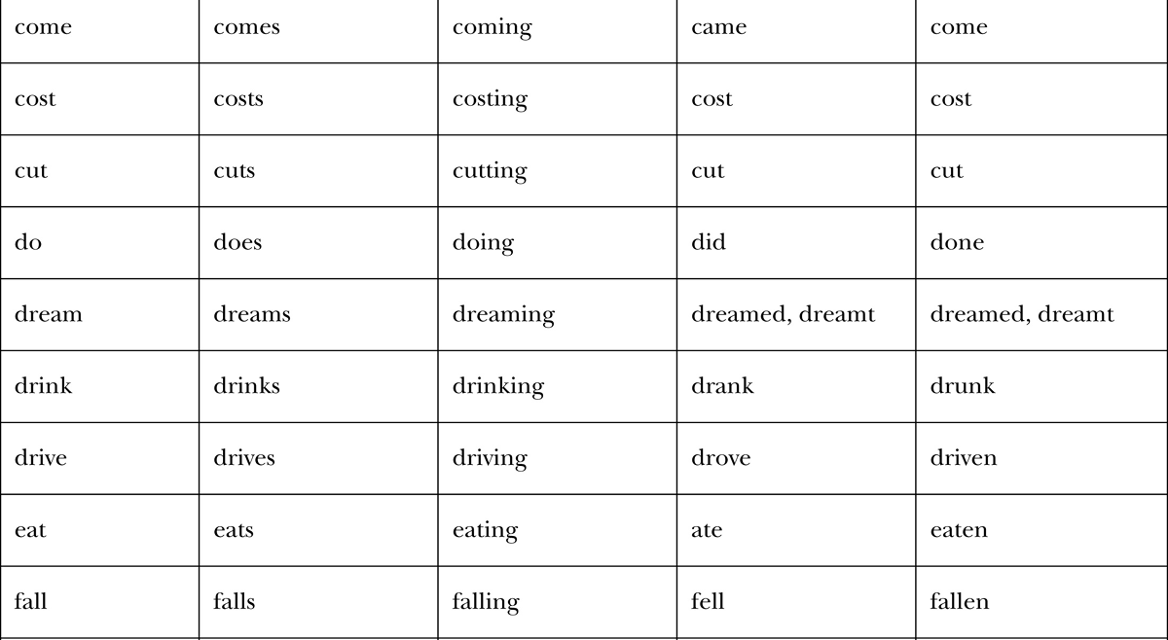
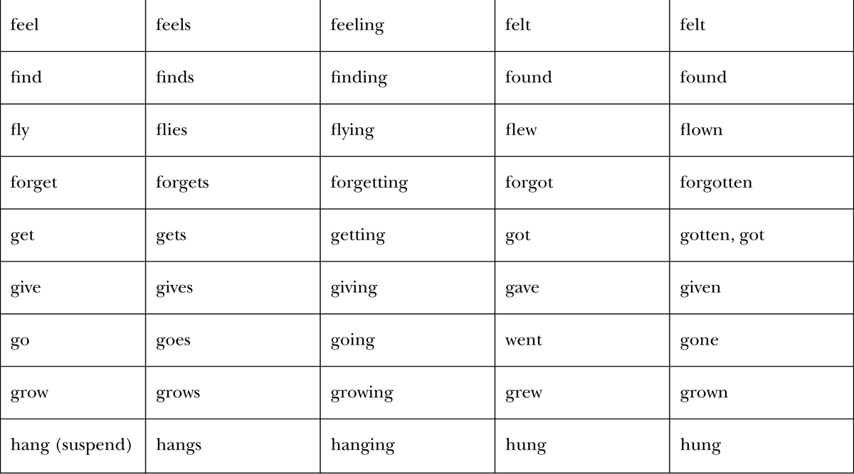
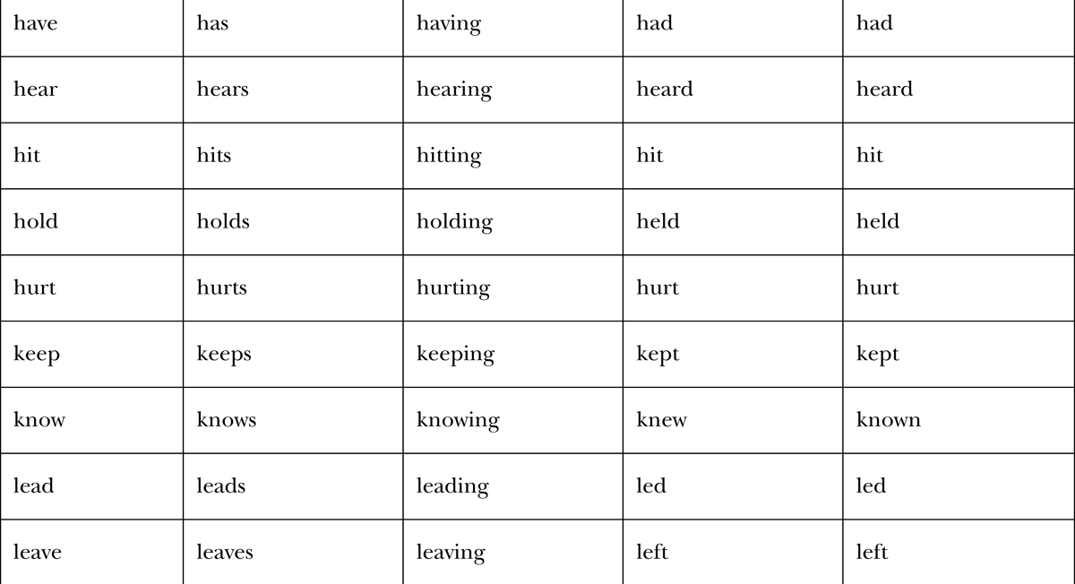
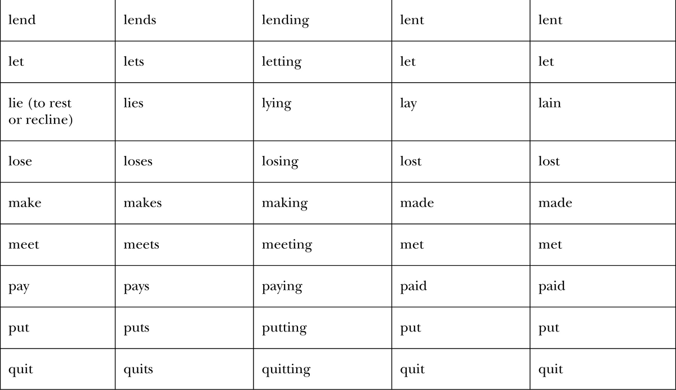
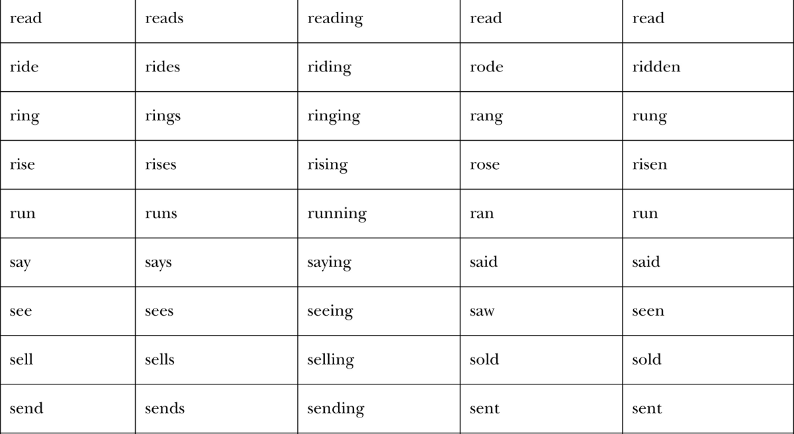
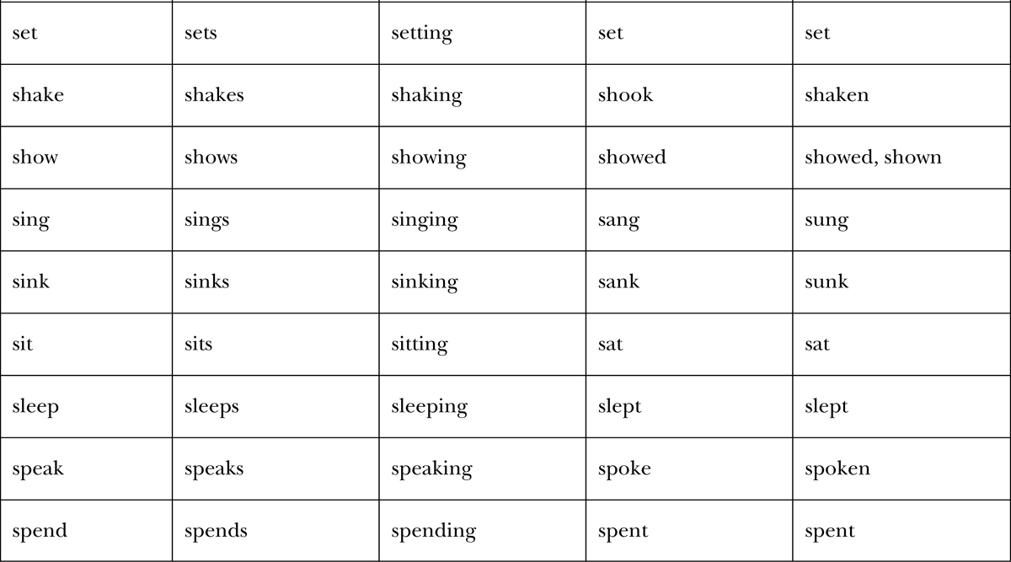
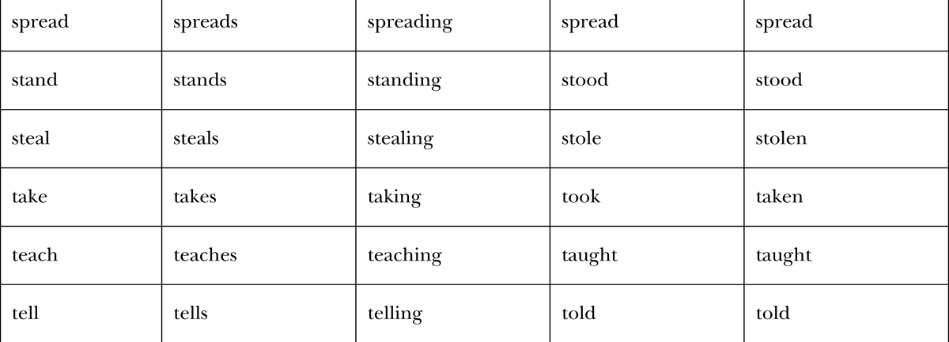
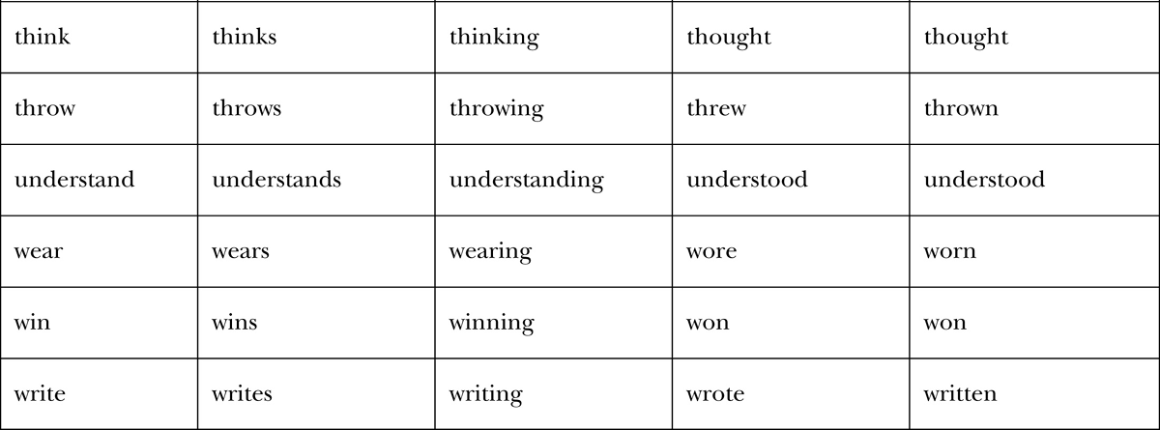

Glossary
ASPECT A grammatical category that provides information about the duration or completeness of an action, a state, or an event. Aspect may also provide information about actions, states, or events in relation to a specific time or to another action, state, or event.
AUXILIARY VERB A specialized verb that provides information about tense, aspect, or modality. Be, have, and do can be used as auxiliary verbs, although they can also be used as main verbs. Words such as must, can, and may are modal auxiliary verbs. Modal auxiliary verbs are used to signal obligation, ability, possibility, and other meanings.
GERUND The -ing form of a verb, functioning as a noun. Some verbs can be followed by gerunds (e.g., I enjoy going to concerts.).
HYPOTHETICAL CONDITIONAL A grammatical structure consisting of two parts: an if clause that expresses an impossible or only slightly possible occurrence and a consequence clause, sometimes introduced by then.
IMPERATIVE A grammatical structure characterized by the presence of the base form of a verb and the absence of a subject. The subject you is usually not expressed (e.g., Be quiet). Imperatives are generally used in instructions, directions, warnings, and commands.
INFINITIVE The base form of a verb preceded by to. When an infinitive follows a verb, it functions as a noun (e.g., We want to see you soon.).
PHRASAL VERB A verb + particle combination that carries a specific meaning (e.g., Turn in your paper.).
PRONOUN Usually a single word, such as it, she, or I, which functions as a noun phrase. A pronoun is marked for person (first, second, or third) and number (singular or plural).
SUBJECT (SINGULAR, PLURAL, NONCOUNT) The noun phrase (sometimes just a single noun or a pronoun) that carries out the action or assumes the state expressed by the verb. Singular subjects refer to one entity; plural subjects refer to more than one entity. Noncount subjects are not able to be counted (e.g., furniture, sugar). A verb conjugated as third person singular is used with a noncount noun.
TENSE A grammatical category that provides information about the placement in time of an action, a state, or an event.
VOICE (ACTIVE AND PASSIVE) The grammatical category that provides information about the way a subject is related to a verb. In the active voice, the subject generally performs an action, whereas in the passive voice, the subject generally undergoes the action.
WH-QUESTIONS Questions that elicit specific pieces of information and that are introduced by question words usually beginning with the letters wand h (e.g., who, what, where, why). The question word how is an exception.
YES/NO QUESTIONS Questions that can be answered “yes” or “no,” although other responses such as “maybe” are possible.

Answer Key

Part I The Present Tense
Unit 1 Simple Present
1-1
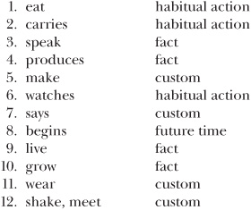

1-2
The correct subjects and verbs are provided. Other parts of the sentence may vary.
1. She always makes strawberry pies for the Fourth of July.
2. I take the garbage out every Tuesday night.
3. It gives me a headache.
4. They come to our house on Labor Day.
5. I use my computer every day.
6. He leaves in ten minutes.
7. They like the theater.
8. She writes poetry and short stories.
9. We listen to the baseball games on KXLE.
10. It contains something fragile.
11. It starts at 9:00.
12. He understands the theory.

1-3
1. He does not go to school every day.
2. My roommate does not like snakes.
3. You do not know my family.
4. The owner does not open the store every day at 8:00.
5. We do not help our neighbors.
6. My friends do not send me letters.
7. I do not feel tired.
8. She does not speak five different languages.
9. They do not study in the library.
10. We do not listen to pop music.
11. They do not grow tomatoes in their backyard.
12. This car does not run well.

1-4
1. He doesn’t go to school every day.
2. My roommate doesn’t like snakes.
3. You don’t know my family.
4. The owner doesn’t open the store every day at 8:00.
5. We don’t help our neighbors.
6. My friends don’t send me letters.
7. I don’t feel tired.
8. She doesn’t speak five different languages.
9. They don’t study in the library.
10. We don’t listen to pop music.
11. They don’t grow tomatoes in their backyard.
12. This car doesn’t run well.

1-5
1. Does the artist show his work at a local gallery?
2. Do they meet on Thursday mornings?
3. Does she work hard?
4. Do you commute to work?
5. Does it seem like a good decision?
6. Does this work require patience?
7. Do the Carsons live in a small town?
8. Don’t you believe my story?
9. Does the patient feel better?
10. Does the lecture end at 5:30?
11. Does the plot involve many characters?
12. Do most students complete the program in four years?

1-6
1. Who knows the answer?
2. How does she look?
3. Why do they always go to that restaurant?
4. How often do they go golfing?
5. Where do we turn left?
6. How much does the notebook cost?
7. Who worries too much?
8. How often do you exercise at the gym?
9. What do Jerry and Carol repair?
10. What does she teach?
11. Whom does Mark blame for his problems?
12. Where do many people go for their vacations?

Unit 2 Be Verb Forms

2-1
1. am
2. are, am
3. are
4. is
5. is
6. are
7. are
8. am
9. is
10. is
11. is
12. are

2-2
1. is
2. are
3. are
4. is
5. are
6. is
7. is
8. are
9. are
10. is
11. is
12. is

2-3
1. She’s a student.
2. I’m an engineer.
3. There’s a test on Tuesday.
4. You’re next.
5. It’s difficult.
6. We’re from Canada.
7. He’s a supervisor.
8. They’re really funny.
9. I’m sick today.
10. There’s a package for you on the table.
11. He’s first on the list.
12. It’s cold in here.

2-4
1. She’s not a student.
2. I’m not an engineer.
3. There’s not a test on Tuesday.
4. You’re not next.
5. It’s not difficult.
6. We’re not from Canada.
7. He’s not a supervisor.
8. They’re not really funny.
9. I’m not sick today.
10. There’s not a package for you on the table.
11. He’s not first on the list.
12. It’s not cold in here.

2-5
1. isn’t
2. aren’t
3. isn’t
4. aren’t
5. aren’t
6. isn’t

2-6
1. Is Portland in the state of Oregon?
2. Is your car in the garage?
3. Is he in a good mood?
4. Are they friends?
5. Is Sam depressed?
6. Is her computer broken?
7. Are there many items on the menu?
8. Is the coffee too hot?
9. Is the city hall the oldest building in town?
10. Is there a bank near here?
11. Is the museum open on Thursday evenings?
12. Are the lights off?

2-7
1. Who is the editor of the local newspaper?
2. How tall is she?
3. Who are they?
4. Where is his roommate right now?
5. When is the graduation ceremony?
6. What color is the house?
7. What is that?
8. Where are the scissors?
9. Who is the producer?
10. Where are the children?
11. How late is the library open?
12. Where are they?

Unit 3 Present Progressive (Be Verb + -ing)
3-1
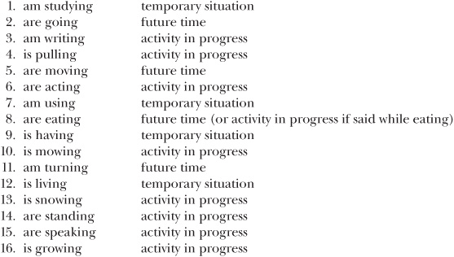

3-2
1. sells
2. is selling
3. am boiling
4. boils
5. visit
6. are visiting
7. goes
8. is going
9. am doing
10. do

3-3
The correct subjects and verbs are provided. Other parts of the sentence may vary.
1. He’s paying for dinner.
2. It’s hailing.
3. We’re meeting in the conference room.
4. Right now they’re losing the game.
5. She’s waiting in line.
6. You’re carrying a heavy backpack.
7. I’m wearing a hat today.
8. We’re reading the same book.
9. She’s calling the movie theater.
10. He’s selling his old bicycle.
11. They’re staying at home tonight.
12. I’m assisting a customer right now.

3-4
1. I am not buying a new car tomorrow.
2. She is not studying.
3. We are not leaving soon.
4. They are not coming with us.
5. Carla is not living with her parents.
6. I am not cooking dinner tonight.
7. The band is not performing tonight.
8. My mother is not visiting this weekend.
9. They are not sleeping.
10. We are not going to the park today.
11. They are not fixing the road.
12. She is not quitting her job.

3-5
1. I’m not buying a new car tomorrow.
2. She’s not studying. OR She isn’t studying.
3. We’re not leaving soon. OR We aren’t leaving soon.
4. They’re not coming with us. OR They aren’t coming with us.
5. Carla’s not living with her parents. OR Carla isn’t living with her parents.
6. I’m not cooking dinner tonight.
7. The band’s not performing tonight. OR The band isn’t performing tonight.
8. My mother’s not visiting this weekend. OR My mother isn’t visiting this weekend.
9. They’re not sleeping. OR They aren’t sleeping.
10. We’re not going to the park today. OR We aren’t going to the park today.
11. They’re not fixing the road. OR They aren’t fixing the road.
12. She’s not quitting her job. OR She isn’t quitting her job.

3-6
1. Is the mail carrier delivering a package to our house?
2. Is the boat sinking?
3. Are they causing trouble?
4. Is he worrying about his course grade?
5. Is Helen publishing her autobiography?
6. Is the teacher inviting everyone in class to a party?
7. Is the committee announcing the winner of the contest today?
8. Is the engineer explaining the process?
9. Is Mandy singing at her sister’s wedding?
10. Is the company expanding?
11. Is Phil arranging the conference?
12. Are the police accusing him of the crime?

3-7
1. What are they eating?
2. Who is coming along?
3. What are we watching on television tonight?
4. What is she showing them?
5. Whom are you meeting?
6. Why are they wearing special clothes?
7. What is he hoping for?
8. What is happening?
9. What are Alex and Terry playing?
10. Where are they moving?
11. Who is staring at us?
12. Who is winning?

Unit 4 Present Perfect

4-1
1. have built
2. have eaten
3. have lent
4. have spoken
5. has fallen
6. have known
7. have sold
8. has rained
9. have kept
10. has spent
11. have cut

4-2
1. He’s rented
2. It’s worked
3. We’ve been
4. They’ve lost
5. She’s waited
6. You’ve reached
7. I’ve applied
8. We’ve developed
9. She’s ignored
10. He’s found
11. They’ve gone
12. I’ve forgotten

4-3
1. They have not chosen a location for the conference.
2. She has not completed her work.
3. We have not studied our options.
4. I have not received my test results.
5. You have not mentioned his name before.
6. He has not reviewed the plans.
7. It has not disappeared.

4-4
1. They haven’t chosen a location for the conference.
2. She hasn’t completed her work.
3. We haven’t studied our options.
4. I haven’t received my test results.
5. You haven’t mentioned his name before.
6. He hasn’t reviewed the plans.
7. It hasn’t disappeared.

4-5
1. Have you put the dishes away?
2. Have they offered her a new job?
3. Have we received good news?
4. Has he checked the oil in the car?
5. Has Jackson obtained a driver’s license?
6. Has the new student arrived?
7. Has Jeanette responded to our message?
8. Have the archaeologists discovered new fossils?
9. Have you made your lunch?
10. Has the business expanded?
11. Has Sarah arranged the meeting?
12. Has the program been successful?

4-6
1. What have they given to charities?
2. Who has appeared on television?
3. How many games has she missed?
4. Who has passed the first part of the test?
5. How many of his novels have you read?
6. What color has Les painted his house?
7. Who has sung at the White House?
8. What has happened?
9. Who has influenced your decision?
10. Which courses has he taken?
11. How many years have you taught English?
12. Whom have they invited to the party?

Unit 5 Present Perfect Progressive

5-1
1. has been hurting
2. has been causing
3. has been exercising
4. have been drinking
5. has been worrying
6. has been earning
7. have been paying
8. have been following
9. have been sitting
10. have been applying
11. have been helping
12. have been rising

5-2
1. He’s been expecting
2. It’s been changing
3. We’ve been developing
4. They’ve been checking
5. She’s been exploring
6. You’ve been complaining
7. I’ve been calculating

5-3
1. He has not been ignoring
2. It has not been improving
3. We have not been commuting
4. They have not been buying
5. She has not been doing
6. You have not been finishing
7. I have not been riding

5-4
1. He hasn’t been ignoring the evidence.
2. It hasn’t been improving much.
3. We haven’t been commuting together this year.
4. They haven’t been buying much lately.
5. She hasn’t been doing her work.
6. You haven’t been finishing your projects on time.
7. I haven’t been riding the bus to school.

5-5
1. Have you been paying all your bills on time?
2. Has the noise been bothering them?
3. Has traffic been moving slowly?
4. Has she been waiting a long time?
5. Have they been reducing the number of accidents?
6. Has the suspect been lying?
7. Have you been reading an interesting novel?
8. Has the government been allowing journalists into the country?
9. Has she been keeping good records?
10. Have they been considering the proposal?
11. Has he been staying close to home?
12. Has she been making progress?

5-6
1. Where has Paula been traveling?
2. How long has he been living in Miami?
3. What have they been searching for?
4. Who has been watching the children?
5. How often have they been going to the Virgin Islands?
6. What has the guide been arranging?
7. Who has been taking notes?
8. How long have you been attending the university?
9. What have they been planning?
10. What has he been talking about?
11. How have you been feeling lately?
12. How long has she been standing there?

Part II The Past Tense
Unit 6 Simple Past

6-1
1. worked
2. waited
3. remembered
4. needed
5. missed
6. sold
7. went
8. met
9. cut
10. wore

6-2
1. lived
2. have lived
3. have studied
4. studied
5. traveled
6. have traveled
7. have worked
8. worked
9. has built
10. built

6-3
1. He did not come to work on time.
2. My roommate did not like the movie.
3. She did not understand the problem.
4. We did not take a wrong turn.
5. The students did not need help with the homework.
6. The driver did not blame me for the accident.
7. I did not listen to the directions.
8. She did not earn a degree in economics.
9. He did not calculate the taxes.
10. They did not complain about the weather.

6-4
1. He didn’t come to work on time.
2. My roommate didn’t like the movie.
3. She didn’t understand the problem.
4. We didn’t take a wrong turn.
5. The students didn’t need help with the homework.
6. The driver didn’t blame me for the accident.
7. I didn’t listen to the directions.
8. She didn’t earn a degree in economics.
9. He didn’t calculate the taxes.
10. They didn’t complain about the weather.

6-5
1. Did they elect a new president?
2. Did she deliver the report?
3. Did you expect us earlier?
4. Did Tho pass his driver’s test?
5. Did the committee explore the issues?
6. Did he explain the problem?
7. Did the director have an appointment at 3:00?
8. Did you forget the map?
9. Did the bank lend him some money?
10. Did they offer him a job?

6-6
1. Who wrote Beloved?
2. Who won the contest?
3. Which way did he turn?
4. How many countries did they travel to?
5. How long did you teach biology?
6. How much did the repair cost?
7. How long did they stay at the party?
8. How far did she run?
9. Where did they move?
10. How far did they climb?

Unit 7 Be Verb Forms

7-1
1. was
2. were
3. were
4. was
5. was
6. were
7. was
8. were
9. was
10. was

7-2
1. was
2. were
3. was
4. was
5. were
6. were
7. was
8. was
9. were
10. was

7-3
1. weren’t
2. wasn’t
3. weren’t
4. wasn’t
5. weren’t
6. wasn’t
7. weren’t
8. weren’t
9. weren’t
10. wasn’t

7-4
1. Was the concert in the park?
2. Was the road under construction?
3. Was everyone on time?
4. Were the textbooks expensive?
5. Was the job stressful?
6. Was the program a success?
7. Were there many apartments for rent?
8. Was the parking lot full?
9. Were the tickets free?
10. Was the computer on?

7-5
1. Who was the president of the United States in 1980?
2. How was the trip?
3. Where were his grandparents from?
4. Where were they?
5. When was the field trip?
6. How long was the gym open on Sunday?
7. What items were on sale?
8. How was the traffic?
9. Who was there?
10. How long was the movie?

Unit 8 Past Progressive (Be Verb + -ing)

8-1
1. was being
2. was ringing
3. was waiting, was dreaming
4. were living
5. was taking, was studying
6. was putting
7. was knocking, was getting
8. was raining
9. were going
10. were cleaning

8-2
1. complete action
2. action in progress
3. action in progress
4. complete action
5. action in progress
6. complete action
7. complete action
8. action in progress
9. action in progress
10. complete action

8-3
1. He was not attending a conference.
2. They were not laughing.
3. I was not complaining about the work.
4. She was not helping us.
5. Ted was not studying last night.
6. They were not paying attention.
7. I was not talking to myself.
8. You were not speaking loud enough.
9. They were not doing their homework.
10. We were not trying hard.

8-4
1. He wasn’t attending a conference.
2. They weren’t laughing.
3. I wasn’t complaining about the work.
4. She wasn’t helping us.
5. Ted wasn’t studying last night.
6. They weren’t paying attention.
7. I wasn’t talking to myself.
8. You weren’t speaking loud enough.
9. They weren’t doing their homework.
10. We weren’t trying hard.

8-5
1. Was the band giving a free concert?
2. Was the light blinking on and off?
3. Were you watching the championship on television?
4. Were they being careful?
5. Was it snowing all day?
6. Were Gabe and Don singing together?
7. Were they closing the store?
8. Were the companies considering a merger?
9. Were they recycling most of the waste products?
10. As young children, were they always getting into trouble?

8-6
1. Where were they protesting?
2. Who was using this computer?
3. What were you watching on television last night?
4. What was the committee discussing?
5. What was bothering them?
6. Who was spreading rumors?
7. Where was he working?
8. How fast was she driving?
9. What was he reading during class today?
10. Where were they standing?

Unit 9 Past Perfect

9-1
1. had attended
2. had held
3. had sold
4. had met
5. had felt
6. had hit
7. had sat
8. had run
9. had snowed
10. had been

9-2
1. arrived, had left
2. had finished, went
3. had assigned, completed
4. was, had worked
5. wore, had given
6. revised, had written
7. had knocked, entered
8. knew, had taken
9. read, had received
10. celebrated, had passed

9-3
1. They had not met
2. it had not changed
3. We had not considered
4. He had not wanted
5. She had not driven
6. You had not spoken
7. I had not sent

9-4
1. They’d met before.
They hadn’t met before.
2. Because it’d changed color, no one could see it.
Because it hadn’t changed color, no one could see it.
3. We’d considered all the possibilities.
We hadn’t considered all the possibilities.
4. He’d wanted help from us.
He hadn’t wanted help from us.
5. She’d driven to the party.
She hadn’t driven to the party.
6. You’d spoken English before you came to the United States.
You hadn’t spoken English before you came to the United States.
7. I’d sent my application in on time.
I hadn’t sent my application in on time.

9-5
1. Hadn’t she called before she arrived?
2. Hadn’t they obtained permission before they started the experiment?
3. Had Pat won the first race before he ran the second race?
4. Had they closed the road?
5. Had they canceled the game without prior notice?

9-6
1. Who had received job offers before they graduated?
2. How many track records had Peter broken by the age of eighteen?
3. How long had she taught English before she went to law school?
4. When had he arrived at the gate?
5. How long had they dated before they got married?

Unit 10 Past Perfect Progressive

10-1
1. had been working
2. had been discussing
3. had been studying
4. had been increasing
5. had been playing
6. had been raining
7. had been watching
8. had been writing
9. had been studying
10. had been working

10-2
1. The supervisor had not been assigning
2. The weather had not been improving
3. Jodi and I had not been following
4. They had not been checking
5. She had not been ignoring
6. You had not been getting
7. I had not been exercising

10-3
1. He hadn’t been expecting
2. It’d been changing
3. We’d been hoping
4. They hadn’t been looking
5. She’d been lying
6. You hadn’t been joking
7. I’d been thinking

10-4
1. Had you been working too hard?
2. Had he been living by himself?
3. Had she been talking too loudly?
4. Had they been waiting a long time?
5. Had the suspect been telling the truth?

10-5
1. Who had been making the arrangements?
2. How long had he been thinking about moving?
3. What had they been using before the new shipment arrived?
4. Who had been leading the discussion when the argument started?
5. How long had they been working on the project?

Part III The Future Tense
Unit 11 Simple Future

11-1
1. will commute
2. will require
3. will give
4. will visit
5. will be
6. will announce
7. will leave
8. will complete
9. will call
10. will expand

11-2
1. They’ll believe
2. I’ll deliver
3. You’ll like
4. It’ll end
5. He’ll help
6. She’ll introduce
7. We’ll sit

11-3
1. He will not finish by tomorrow.
2. You will not have a lot of fun there.
3. She will not know the answer.
4. We will not ignore the problem.
5. They will not keep your secret.
6. He will not lie to you.
7. I will not need help with my homework.
8. Marian will not be alone.
9. I will not mention your name.
10. They will not be late.

11-4
1. He won’t finish by tomorrow.
2. You won’t have a lot of fun there.
3. She won’t know the answer.
4. We won’t ignore the problem.
5. They won’t keep your secret.
6. He won’t lie to you.
7. I won’t need help with my homework.
8. Marian won’t be alone.
9. I won’t mention your name.
10. They won’t be late.

11-5
1. Will they tell us on Friday?
2. Will she report the incident?
3. Will you laugh at my mistakes?
4. Will Mitch need some help?
5. Will the noise bother you?
6. Will he lend us some money?
7. Will Dr. Silvis be free at 4:00?
8. Will we meet later?
9. Will they use your plan?
10. Will Federal Express deliver the package to our house?

11-6
1. Who will repair his car?
2. When will the class meet?
3. When will Rhonda finish the report?
4. How much will it cost?
5. Whom will they blame for the mistake?
6. Who will choose the scholarship winners?
7. How long will the supervisor be on vacation?
8. What will they complain about?
9. Who will lead the discussion?
10. When will the dance group perform?
Unit 12 Be Going To

12-1
1. is going to be
2. are going to build
3. is going to buy
4. am going to cancel
5. are going to climb
6. are going to celebrate
7. is going to call
8. is going to come
9. is going to deliver
10. are going to elect
12-2
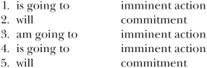

12-3
1. Taxes are not going to increase
2. It is not going to snow
3. We are not going to go
4. He is not going to listen
5. She is not going to travel
6. You are not going to have
7. I am not going to forget

12-4
1. He’s not going to come OR He isn’t going to come
2. It’s going to rain
3. I’m going to clean
4. They’re not going to believe OR They aren’t going to believe
5. She’s not going to call OR She isn’t going to call
6. You’re going to do
7. I’m not going to cook

12-5
1. Are they going to consider your proposal?
2. Are you going to enter the park at the north gate?
3. Is the doctor going to explain the procedure?
4. Are we going to explore our new neighborhood today?
5. Is he going to fix it for free?
6. Are you going to follow us?
7. Is she going to get into trouble?
8. Is it going to happen soon?
9. Is he going to like this idea?
10. Are we going to look for a new apartment today?

12-6
1. Who is going to move to Chile?
2. How much is she going to earn?
3. When are we going to eat?
4. When are they going to improve the roads?
5. When are you going to develop the film?
6. Whom are they going to invite?
7. When are the legislators going to discuss the bill?
8. Where is he going to live?
9. Who is going to march in the parade?
10. When is the eclipse going to occur?

Unit 13 Future Progressive (Will Be Verb + -ing)

13-1
1. will be representing
2. will be leaving
3. will be following
4. will be waiting
5. will be watching
6. will be producing
7. will be providing
8. will be snowing
9. will be wearing
10. will be opening

13-2
1. They will not be appearing
2. It will not be starting
3. We will not be reading
4. He will not be arriving
5. She will not be staying
6. You will not be living
7. I will not be making

13-3
1. He won’t be joining
2. It’ll be affecting
3. I’ll be treating
4. They won’t be needing
5. She won’t be arriving
6. you’ll be flying
7. I won’t be thinking

13-4
1. Will I be seeing you next week?
2. Will they be traveling by bus?
3. Will Takamitsu be assisting Heather?
4. Will they be offering special packages at the end of the season?
5. Will you be checking your e-mail daily?

13-5
1. Who will be taking notes?
2. Who will be receiving an award?
3. Where will they be sitting?
4. How far will you be driving on your first day?
5. When will she be finishing her project?

Unit 14 Future Perfect

14-1
1. will have left
2. will have written
3. will have introduced
4. will have flown
5. will have eaten

14-2
1. You will not have rested
2. they will not have eaten
3. We will not have finished
4. Mark will not have slept
5. She will not have saved

14-3
1. they’ll have completed
2. he won’t have finished
3. you’ll have recovered
4. They won’t have made
5. She’ll have given

14-4
1. Will the landscape have changed by the time he’s an adult?
2. By July 11, will we have made our decision?
3. By the time you start your new job, will you have finished your degree?
4. By the time we get home, will he have called already?
5. When we get to the movie theater, will the movie have started already?

14-5
1. will have become the record holder?
2. will she have lived in Moscow when her family arrives?
3. will Andy have run?
4. will they have spent?
5. will he have written?

Unit 15 Future Perfect Progressive

15-1
1. will have been living
2. will have been discussing
3. will have been practicing
4. will have been playing
5. will have been working

15-2
1. they will not have been talking
2. the subways will not have been running
3. they will not have been producing
4. the dance troupe will not have been performing
5. she will not have been working

15-3
1. they won’t have been working
2. they’ll have been broadcasting
3. we’ll have been renting
4. they’ll have been returning
5. he won’t have been assisting

15-4
1. will have been making the schedule for five years?
2. will the dance contestants have been dancing?
3. will we have been using this computer?
4. will you have been working on this paper?
5. will Ron have been keeping a journal?

Part IV Imperative, Passive, and Hypothetical Conditional
Unit 16 Imperative

16-1
1. answer
2. Have
3. Open
4. be
5. Finish
6. Call
7. Bake
8. Meet
9. Turn
10. Drive

16-2
1. Do not be
Don’t be late!
2. Do not run
Don’t run on the deck of the pool.
3. Do not forget
Don’t forget your homework.
4. Do not lie
Don’t lie to me.
5. Do not shout
Don’t shout at us.
6. Do not drink
Don’t drink the water.
7. Do not start
Don’t start the car yet.
8. Do not blame
Don’t blame me.
9. Do not boil
Don’t boil the water too long.
10. Do not break
Don’t break anything.

16-3
1. Let’s make
2. Let’s not forget
3. Let’s not stay
4. Let’s call
5. Let’s celebrate

Unit 17 Passive

17-1
1. will be rewarded
He’ll be rewarded for his work.
2. were affected
They were affected by the changes in the tax law.
3. are delivered
They’re delivered daily.
4. are grown
They’re grown in Idaho.
5. were announced
They were announced yesterday.
6. will be changed
They’ll be changed next week.
7. will be rescheduled
It’ll be rescheduled.
8. are invited
They’re invited to the party.
9. was blamed
She was blamed for the error.
10. was destroyed It
was destroyed.

17-2
1. is being broadcast (OR broadcasted)
It’s being broadcast (OR broadcasted) around the world.
2. are being developed
They’re being developed.
3. was being carried
It was being carried to the plane when one of the suitcases popped open.
4. were being discussed
They were being discussed when we arrived.
5. is being considered
It’s being considered.
6. were being checked
They were being checked when the alarm rang.
7. are being elected
They’re being elected this year.
8. is being closed
It’s being closed because of safety problems.
9. were being ignored
They were being ignored by the politicians.
10. are being collected
They’re being collected for the poor.

17-3
1. has been promoted
He’s been promoted.
2. will have been assigned
They’ll have been assigned by the time we arrive.
3. had been delayed
They’d been delayed at the airport, so they were late.
4. will have been finished
It’ll have been finished when the director meets with us.
5. had been praised
It’d been praised highly.
6. will have been notified
We’ll have been notified of any problems before we leave.
7. have been made
They’ve been made.
8. has been offered
It’s been offered to Laila.
9. has been revised
It’s been revised.
10. had been improved
They’d been improved since my previous visit.

17-4
1. The game was not canceled.
2. Rita has not been fired.
3. By this time next year, the project will not have been completed.
4. Some of the important issues are not being discussed.
5. Our bags are not being searched.
6. Your x-rays will not be returned to you.
7. The recent findings are not being presented to the public.
8. The cell phone had not been taken from the car.
9. This computer has not been used before.
10. The document is not being prepared by the secretary.

17-5
1. Were all questions answered?
2. Has everyone been notified of the cancellation?
3. Will the basketball game be broadcast (OR broadcasted)?
4. Is the road being repaired?
5. Had enough evidence been collected?
6. Was he impressed by the report?
7. Have the costs for the project been calculated?
8. Are jobs being cut?
9. Are solutions to the problem being explored?
10. Will the clock be fixed tomorrow?

17-6
1. Who has been elected?
2. What was explored?
3. Who was given a scholarship?
4. What is grown in Hawaii?
5. Who is being honored at the special dinner tonight?
6. When are the invitations being sent?
7. When were the books moved to the new library?
8. Where are the new lights being installed?
9. How many credits are required for graduation?
10. What was damaged in the fire?

Unit 18 Hypothetical Conditional

18-1
1. were, would change
2. checked, would know
3. commuted, would cost
4. had, would go
5. visited, would meet
6. mailed, would receive
7. lowered, would shop
8. earned, would buy
9. exercised, would be
10. were, would tell

18-2
1. had rained, would have canceled
2. had been, would have been
3. had known, would have taken
4. had followed, would have been
5. had studied, would have passed
6. had been, would have received
7. had raised, would have protested
8. had repaired, would have left
9. had revised, would have been
10. had been, would have hired

Part V Phrasal Verbs and Modal Auxiliary Verbs
Unit 19 Phrasal Verbs
19-1
go/goes out, went out, will go out
am/is/are going out, was/were going out, will be going out
has/have gone out, had gone out, will have gone out
has/have been going out, had been going out, will have been going out

19-2
1. has taken away
2. was putting on
3. will find out
4. am looking up
5. will be signing up
6. had put off
7. will have read through
8. has been putting out
9. will have been going over
10. take out
11. pointed out
12. had been paying back
19-3
am/is/are set up, was/were set up, will be set up
am/is are being set up, was/were being set up
has/have been set up, had been set up, will have been set up

19-4
1. had been eaten up
2. was blocked in
3. has been put out
4. will be blown up
5. is being slowed down
6. is brought about
7. was being broken into
8. will have been brought out

19-5
1. She brought the books back yesterday.
She brought them back yesterday.
2. They called the game off.
They called it off.
3. I checked the book out on Monday.
I checked it out on Monday.
4. I crossed some names out.
I crossed them out.
5. Someone turned the washing machine off.
Someone turned it off.
6. I called my parents up last night.
I called them up last night.
7. She closed her suitcase up and put it on the scale.
She closed it up and put it on the scale.
8. I cleaned my desk out this morning.
I cleaned it out this morning.
9. She wrote the number down.
She wrote it down.
10. They gave their old furniture away.
They gave it away.
11. Victor helped his sister out.
Victor helped her out.
12. She took a map down and gave it to us.
She took it down and gave it to us.

19-6
1. Jacob is not writing down the address.
2. She has not booted up the computer.
3. The hot weather was not wearing us down.
4. The books were not brought back yesterday.
5. The painting on the sidewalk has not been washed off.
6. I am not bringing my friend over tonight.
7. They do not vote down most proposals.
8. He did not make up the story.
9. I will not print out my paper on that printer.
10. The report was not turned in on time.
11. She did not set it down carefully.
12. They had not been locked out of their car before.

Unit 20 Modal Auxiliary Verbs

20-1
1. will
2. should
3. may
4. must
5. can
6. would
7. May
8. must
9. may
10. will
11. should
12. Can
13. may
14. would

20-2
1. are going to
2. ought to
3. used to
4. have to
5. is able to
6. used to
7. ought to
8. have to
9. are able to
10. is going to

20-3
1. was going to
2. ought to
3. had to
4. was able to
5. was going to
6. ought to
7. had to
8. were able to

20-4
1. might [modal], be able to [semi-modal]
2. are going to [semi-modal], be able to [semi-modal]
3. might [modal], have to [semi-modal]
4. are going to [semi-modal], have to [semi-modal]
5. will [modal], have to [semi-modal]

20-5
1. You should not
2. We cannot
3. Martin is not able to
4. The supervisor is not going to
5. They may not
6. You must not
7. we would not
8. they will not
9. I do not have to
10. You should not

20-6
1. You shouldn’t smoke in this restaurant.
2. We can’t escape the heat today.
3. Martin isn’t able to find his books.
4. The supervisor isn’t going to be happy.
5. No contraction possible
6. You mustn’t tell anyone.
7. When we were little, we wouldn’t go inside until 10:00.
8. For some reason, they won’t answer their phone.
9. Tomorrow, I don’t have to get up early.
10. You shouldn’t worry so much.

20-7
1. should have
2. should have
3. should have OR could have OR ought to have
4. may have been OR might have been
5. must have
6. should have
7. may have OR might have
8. should have
9. must have
10. should have been OR could have been OR ought to have been

Part VI Gerund and Infinitive Complements
Unit 21 Gerunds

21-1
1. having
2. being surprised
3. having mentioned
4. trying
5. having been invited
6. eating
7. having been chosen
8. reviewing
9. having been
10. being treated
11. stopping
12. being given
13. playing
14. damaging
15. being introduced

21-2
The verbs and possible gerunds are provided. Other parts of the sentence may vary.
1. I enjoy visiting my relatives.
2. I have avoided writing letters.
3. I dislike doing chores on the weekend.
4. I liked being told the story about the three little pigs.
5. I miss seeing my friend Judy.

Unit 22 Infinitives

22-1
1. to be working
2. to pay
3. to have earned
4. to have fainted
5. to be hired
6. to help
7. to have been leaked
8. to be networking
9. to have received
10. to be given
11. to meet
12. to stay
13. to turn in
14. to move
15. to close

22-2
The verbs and infinitives are provided. Other parts of the sentence may vary.
1. I plan to go to the park.
2. I intend to be right here.
3. I need to buy a new notebook.
4. I want to have a pizza.
5. I expect to study chemistry.

22-3
1. him to exercise
2. us to attend
3. my sister to ride
4. me to turn
5. people to touch
6. Brent and me to be
7. local artists to hang
8. the protesters to leave
9. me to rethink
10. employers to provide
11. Robyn to major
12. everyone to conserve

Unit 23 Gerunds or Infinitives
23-1
